**PROJECT**

**Disease Model**

**Nikki Rastogi**

**Business Problem:**

A sprawling hospital system struggles with clunky data management, especially for diverse diseases. Patient information, disease progression, medication, treatment plans, and staff details are scattered across the facility, hindering efficiency and compliance. To streamline operations, boost care, and unlock valuable insights, a centralized data fortress is required.

Given the diverse array of diseases, numerous patients, and multiple healthcare providers, the current data management poses difficulties. Consequently, the hospital aims to develop a relational database system that can systematically store and organize this information, facilitating efficient data retrieval, updates, and analysis. This initiative is crucial for compliance with healthcare regulations, enhancing patient care, and optimizing hospital operations.

Furthermore, the hospital envisions the implementation of a data warehouse solution to conduct advanced analytics and extract meaningful insights from the data. This analytical capability is expected to unveil patterns in disease progression, assess the effectiveness of treatments, streamline resource management, and enhance overall healthcare delivery.

The desired end solution must prioritize security, scalability, and performance, ensuring real-time access to data when required. It should also possess the capacity to handle batch data processing and seamlessly integrate with other systems within the hospital's IT infrastructure.

To design an **ER diagram** for the **Disease** database, first, we need to identify the main entities.

For this hospital scenario, the primary entities could be:

***Patients***

***Diseases***

***Medications***

***Treatment Plan***

***vaccine***

***Doctors***

***Nurses***

***Treatments***

***Hospital_Wards***

***Appointments***

Let's define attributes for these entities:

**Patients**

* + PatientID (Primary Key)
  + FirstName
  + LastName
  + DOB
  + Gender
  + Contact
  + Address
  + WardID (Foreign Key referencing Hospital_Wards.WardID)

**Diseases**

* + DiseaseID (Primary Key)
  + DiseaseName
  + DiseaseType

**Medications**

* + MedicationID (Primary Key)
  + MedicationName
  + MedDosage
  + PatientID (Foreign Key referencing Patients.PatientID)
  + DoctorID (Foreign Key referencing Doctors.DoctorID)
  + DiseaseID (Foreign Key referencing Diseases.DiseaseID)

**Vaccine**

* VaccineID (Primary Key)
* VaccineName
* Manufacture
* Efficiency
* VaccineDosage
* PatientID (Foreign Key referencing Patients.PatientID)

**Doctors**

* + DoctorID (Primary Key)
  + DocFirstName
  + DocLastName
  + Specialty
  + Contact

**Nurses**

* + NurseID (Primary Key)
  + NurFirstName
  + NurLastName
  + Contact

**Treatments**

* + TreatmentID (Primary Key)
  + Plan
  + StartDate
  + EndDate
  + DoctorID (Foreign Key referencing Doctors.DoctorID)
  + DiseaseID (Foreign Key referencing Diseases.DiseaseID)
  + MedicationID (Foreign Key referencing Medications.MedicationID)
  + NurseID (Foreign Key referencing Nurses.NurseID)

**Hospital_Wards**

* + WardID (Primary Key)
  + WardName
  + NurseID (Foreign Key referencing Nurses.NurseID)

**Appointments**

* + AppointmentID (Primary Key)
  + Date
  + Time
  + PatientID (Foreign Key referencing Patients.PatientID)
  + DoctorID (Foreign Key referencing Doctors.DoctorID)
  + TreatmentID (Foreign Key referencing Treatments.TreatmentID)

**PatientDiseases:** (Many-to-Many Relationship Table)

* + PatientID (Foreign Key referencing Patients.PatientID)
  + DiseaseID (Foreign Key referencing Diseases.DiseaseID)

**PatientVaccines** (Many-to-Many Relationship Table)**:**

* + PatientID (Foreign Key referencing Patients.PatientID)
  + VaccineID (Foreign Key referencing Vaccine.VaccineID)

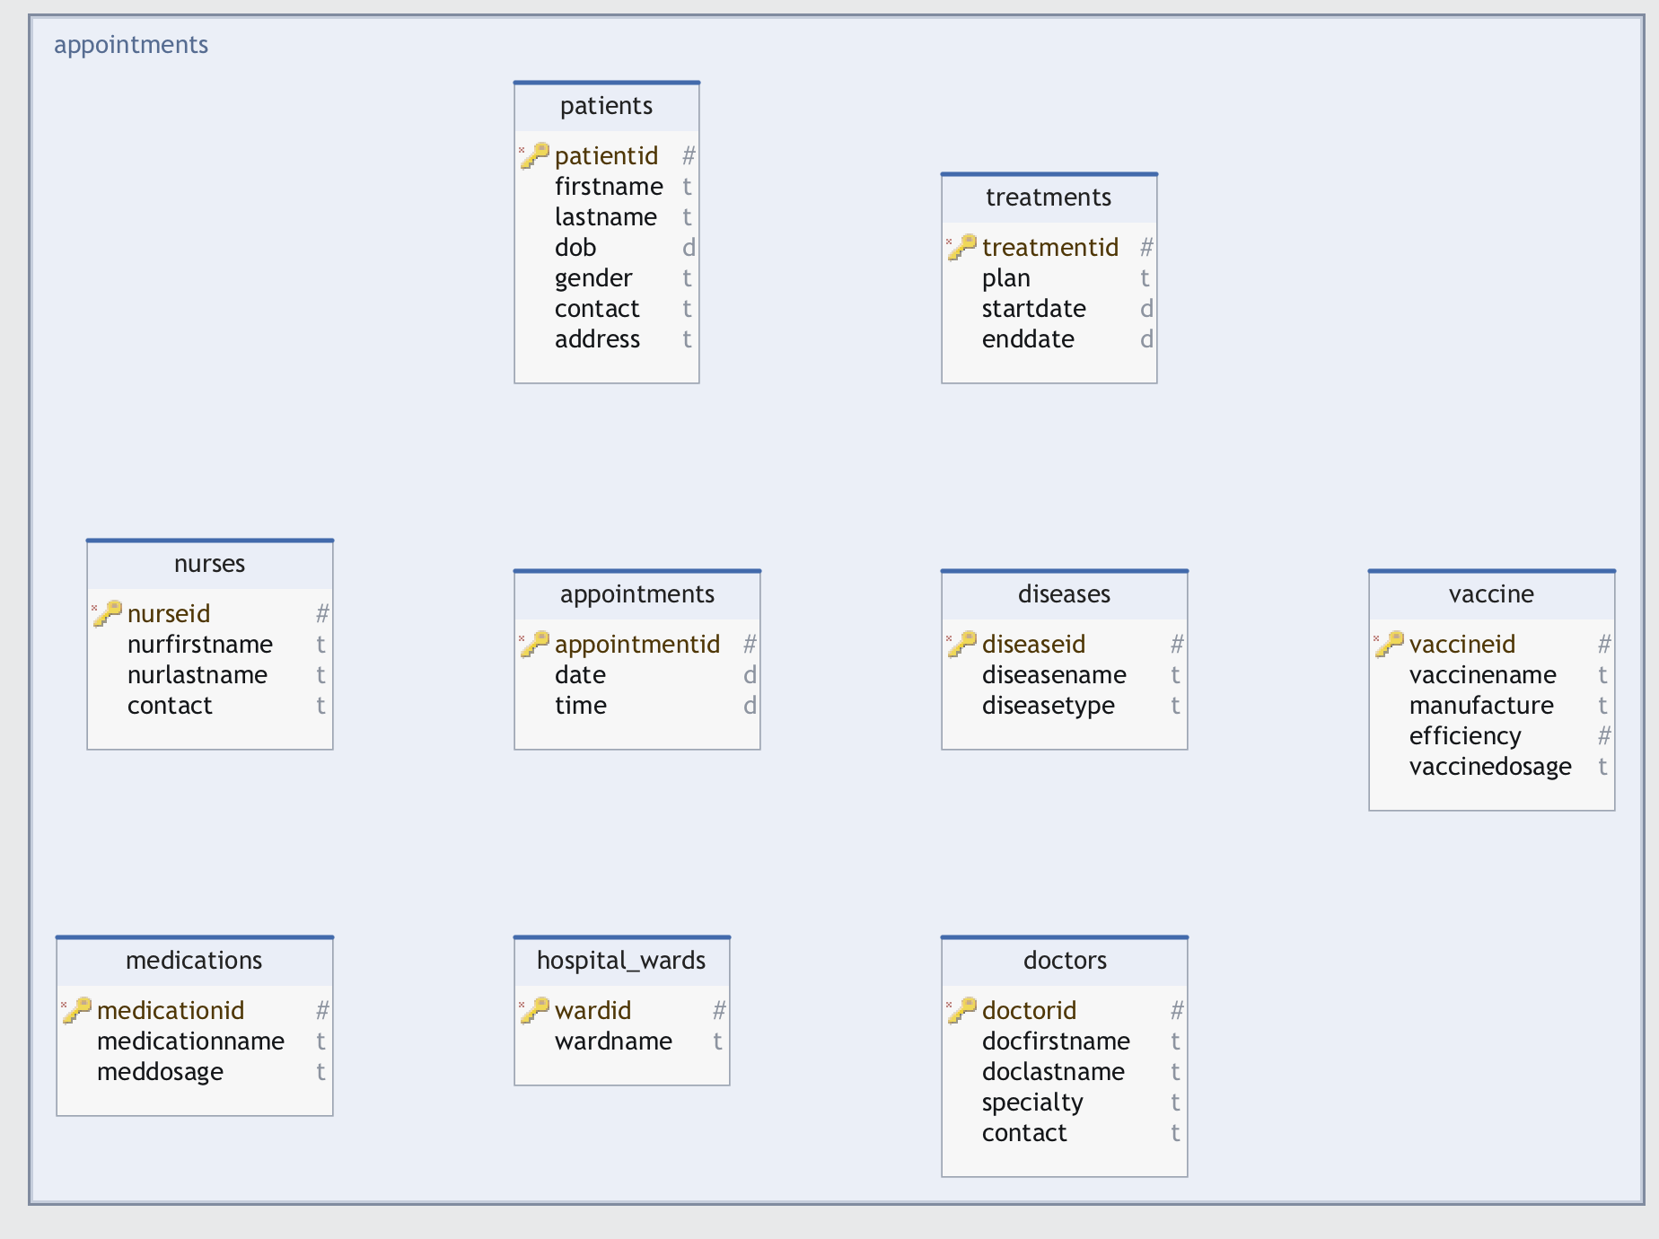

**SQL:**

**-- Create Patients table**

CREATE TABLE Patients (

PatientID SERIAL PRIMARY KEY,

FirstName VARCHAR(50),

LastName VARCHAR(50),

DOB DATE,

Gender VARCHAR(10),

Contact VARCHAR(20),

Address VARCHAR(100)

);

**-- Create Diseases table**

CREATE TABLE Diseases (

DiseaseID SERIAL PRIMARY KEY,

DiseaseName VARCHAR(50),

DiseaseType VARCHAR(50)

**);**

**-- Create Medications table**

CREATE TABLE Medications (

MedicationID SERIAL PRIMARY KEY,

MedicationName VARCHAR(50),

MedDosage VARCHAR(20)

);

**-- Create Vaccine table**

CREATE TABLE Vaccine (

VaccineID SERIAL PRIMARY KEY,

VaccineName VARCHAR(50),

Manufacture VARCHAR(50),

Efficiency DECIMAL(5, 2),

VaccineDosage VARCHAR(20)

);

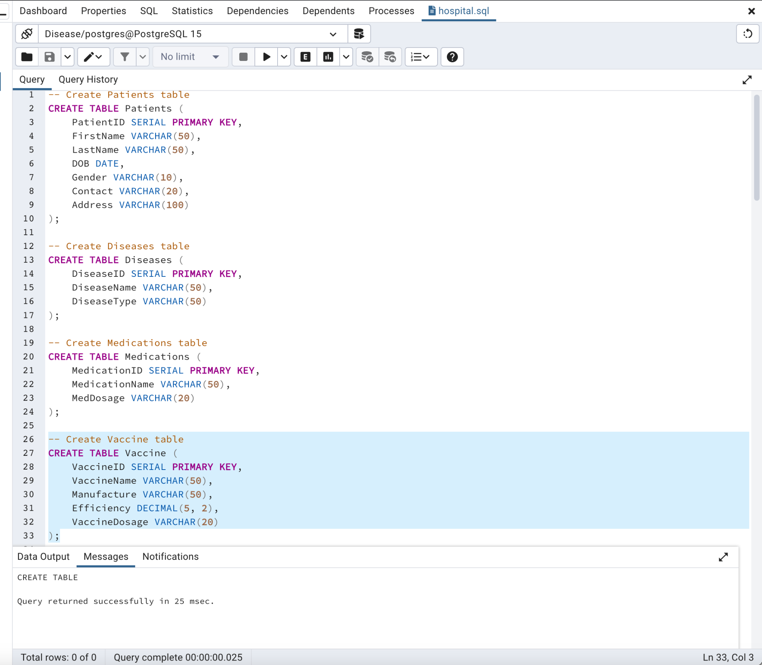

**-- Create Doctors table**

CREATE TABLE Doctors (

DoctorID SERIAL PRIMARY KEY,

DocFirstName VARCHAR(50),

DocLastName VARCHAR(50),

Specialty VARCHAR(50),

Contact VARCHAR(20)

);

**-- Create Nurses table**

CREATE TABLE Nurses (

NurseID SERIAL PRIMARY KEY,

NurFirstName VARCHAR(50),

NurLastName VARCHAR(50),

Contact VARCHAR(20)

);

**-- Create Treatments table**

CREATE TABLE Treatments (

TreatmentID SERIAL PRIMARY KEY,

Plan VARCHAR(100),

StartDate DATE,

EndDate DATE

);

**-- Create Hospital_Wards table**

CREATE TABLE Hospital_Wards (

WardID SERIAL PRIMARY KEY,

WardName VARCHAR(50)

);

**-- Create Appointments table**

CREATE TABLE Appointments (

AppointmentID SERIAL PRIMARY KEY,

Date DATE,

Time TIME

);

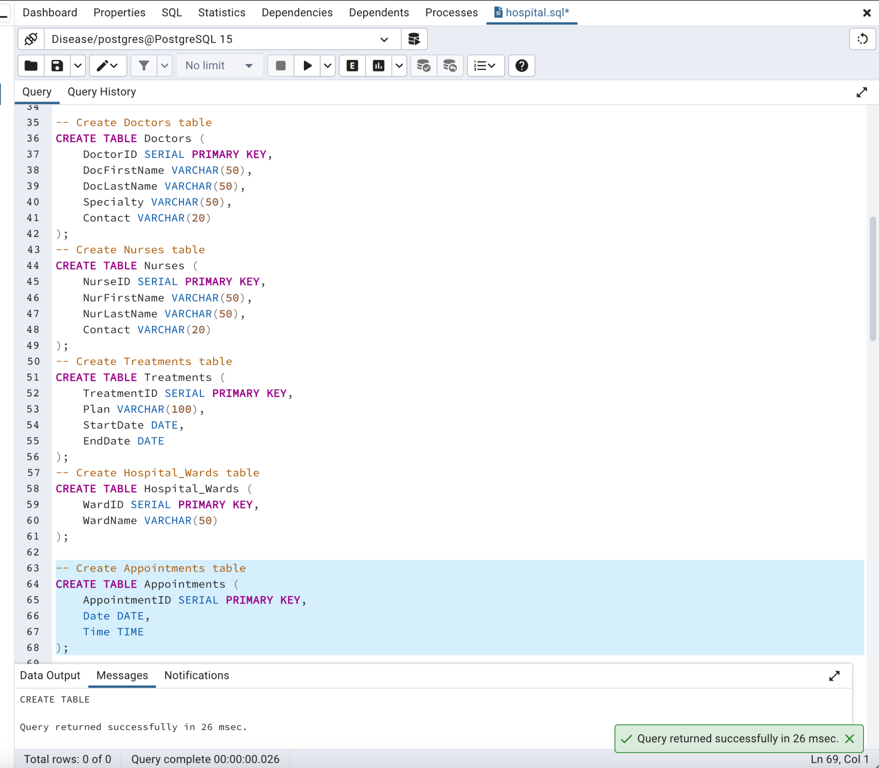

**Relationships:**

* **Patients-Diseases: Many-to-Many**
  + Explanation: A patient can have multiple diseases, and a disease can affect multiple patients.
* **Patients-Vaccine: Many-to-Many**
  + Explanation: A patient can receive multiple vaccines, and a vaccine can be administered to multiple patients.
* **Doctors-Treatments: One-to-Many**
  + Explanation: This establishes a one-to-many relationship where each treatment is associated with one doctor, but a doctor can be associated with multiple treatments.
* **Diseases-Treatments: One-to-Many**
  + Explanation: This establishes a one-to-many relationship where each treatment is associated with one disease, but a disease can be associated with multiple treatments.
* **Medications-Treatments: One-to-Many**
  + Explanation: This establishes a one-to-many relationship where each treatment is associated with one medication, but a medication can be associated with multiple treatments.
* **Nurses-Treatments: One-to-Many**
  + Explanation: This establishes a one-to-many relationship where each treatment is associated with one nurse, but a nurse can be associated with multiple treatments.
* **Patients-Hospital_Wards: One-to-Many**
  + Explanation: This establishes a one-to-many relationship where each patient is assigned to one hospital ward, but a ward can have multiple patients.
* **Appointments: One-to-Many**
  + Explanation: This establishes one-to-many relationships:
  + Each appointment is associated with one patient.
  + Each appointment is associated with one doctor.
  + Each appointment is associated with one treatment.

**Query to represent relationship:**

**-- Create PatientDiseases table for many-to-many relationship**

CREATE TABLE PatientDiseases (

PatientID INT NOT NULL,

DiseaseID INT NOT NULL,

PRIMARY KEY (PatientID, DiseaseID),

FOREIGN KEY (PatientID) REFERENCES Patients(PatientID),

FOREIGN KEY (DiseaseID) REFERENCES Diseases(DiseaseID)

);

**-- Create PatientVaccines table for many-to-many relationship**

CREATE TABLE PatientVaccines (

PatientID INT NOT NULL,

VaccineID INT NOT NULL,

PRIMARY KEY (PatientID, VaccineID),

FOREIGN KEY (PatientID) REFERENCES Patients(PatientID),

FOREIGN KEY (VaccineID) REFERENCES Vaccine(VaccineID)

);

**-- Alter Patients table to add a foreign key for a one-to-many relationship with Hospital_Wards**

ALTER TABLE Patients

ADD COLUMN WardID INT NOT NULL,

ADD FOREIGN KEY (WardID) REFERENCES Hospital_Wards(WardID);

**-- Alter Treatments table to add foreign keys for one-to-many relationships with Doctors, Diseases, Medications, Nurses**

ALTER TABLE Treatments

ADD COLUMN DoctorID INT NOT NULL,

ADD COLUMN DiseaseID INT NOT NULL,

ADD COLUMN MedicationID INT NOT NULL,

ADD COLUMN NurseID INT NOT NULL,

ADD FOREIGN KEY (DoctorID) REFERENCES Doctors(DoctorID),

ADD FOREIGN KEY (DiseaseID) REFERENCES Diseases(DiseaseID),

ADD FOREIGN KEY (MedicationID) REFERENCES Medications(MedicationID),

ADD FOREIGN KEY (NurseID) REFERENCES Nurses(NurseID);

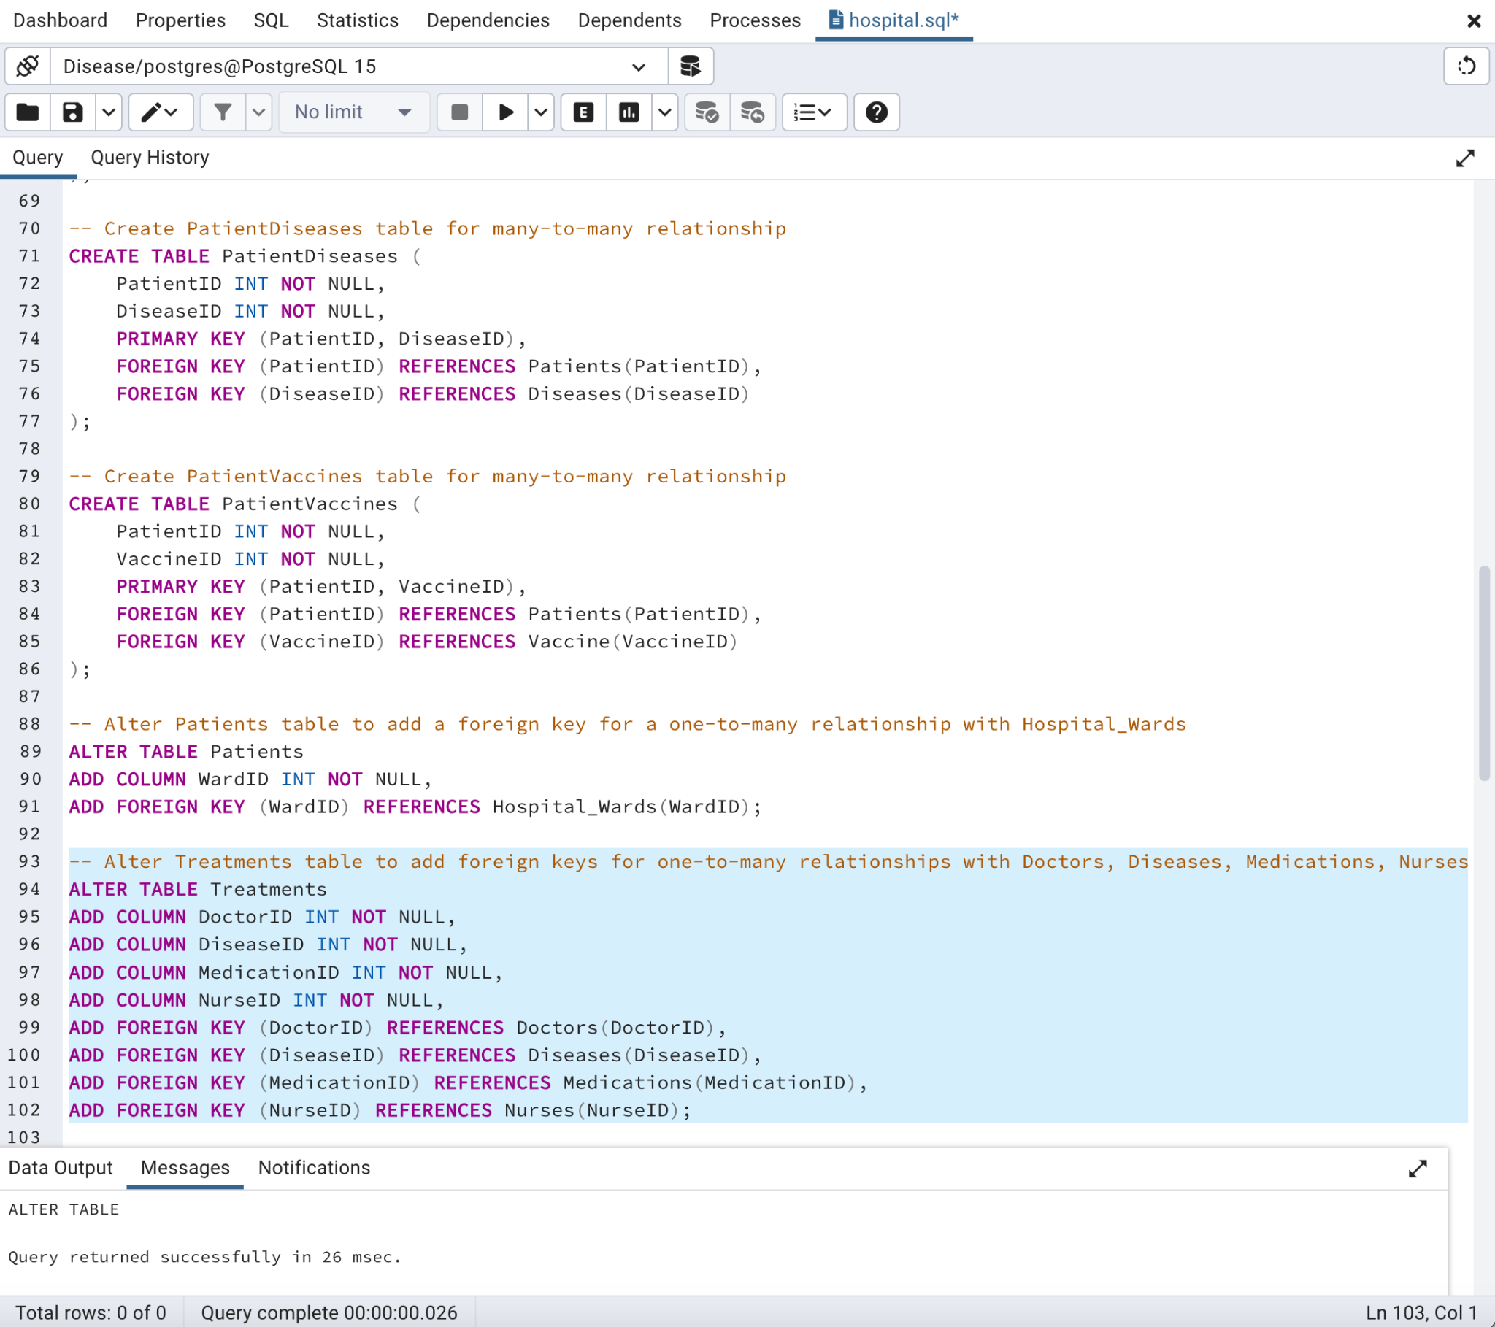

**-- Alter Hospital_Wards table to add a foreign key for a one-to-many relationship with Nurses table**

ALTER TABLE Hospital_Wards

ADD COLUMN NurseID INT NOT NULL,

ADD FOREIGN KEY (NurseID) REFERENCES Nurses(NurseID);

**-- Alter Medications table to add foreign key references to Patients, Doctors, Diseases**

ALTER TABLE Medications

ADD COLUMN PatientID INT NOT NULL,

ADD COLUMN DoctorID INT NOT NULL,

ADD COLUMN DiseaseID INT NOT NULL,

ADD FOREIGN KEY (PatientID) REFERENCES Patients(PatientID),

ADD FOREIGN KEY (DoctorID) REFERENCES Doctors(DoctorID),

ADD FOREIGN KEY (DiseaseID) REFERENCES Diseases(DiseaseID);

**-- Add foreign keys to Appointments for one-to-many relationships with Patients, Doctors, Treatments**

ALTER TABLE Appointments

ADD PatientID INT NOT NULL,

ADD DoctorID INT NOT NULL,

ADD TreatmentID INT NOT NULL,

ADD FOREIGN KEY (PatientID) REFERENCES Patients(PatientID),

ADD FOREIGN KEY (DoctorID) REFERENCES Doctors(DoctorID),

ADD FOREIGN KEY (TreatmentID) REFERENCES Treatments(TreatmentID);

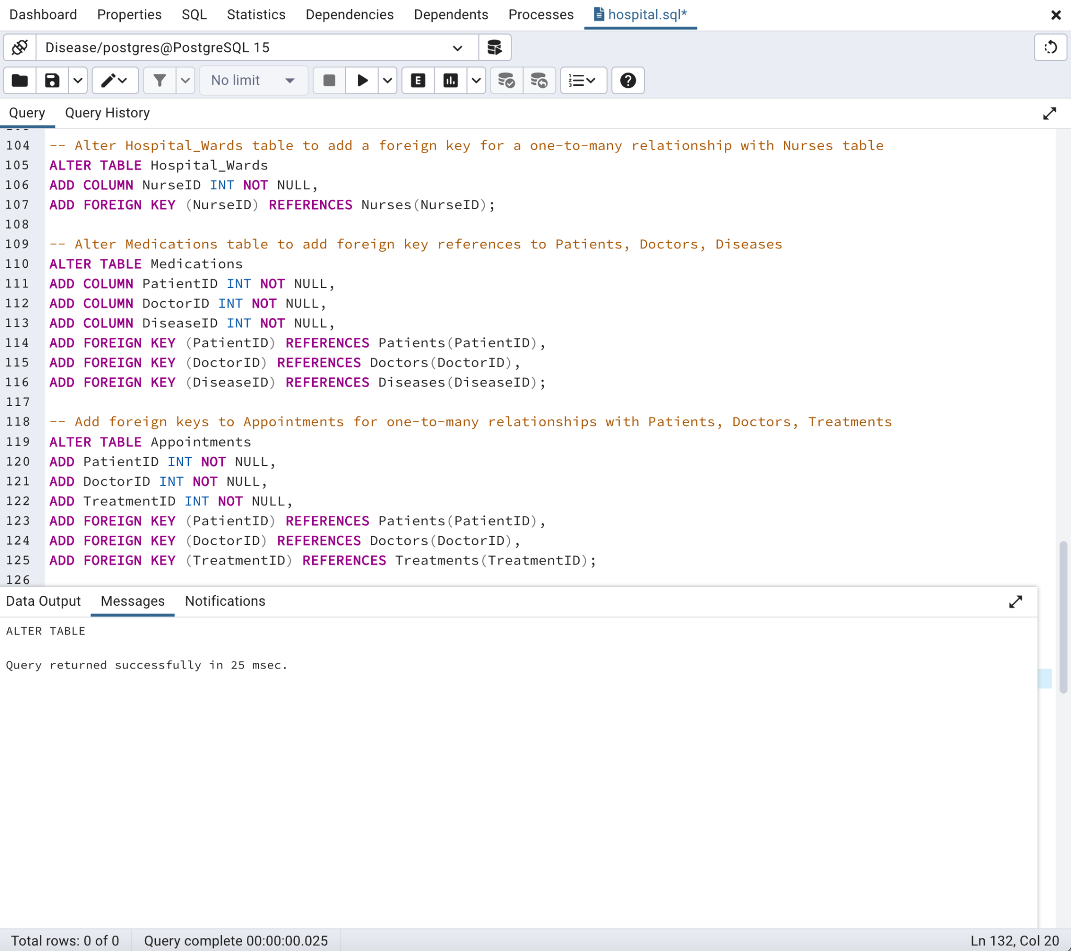

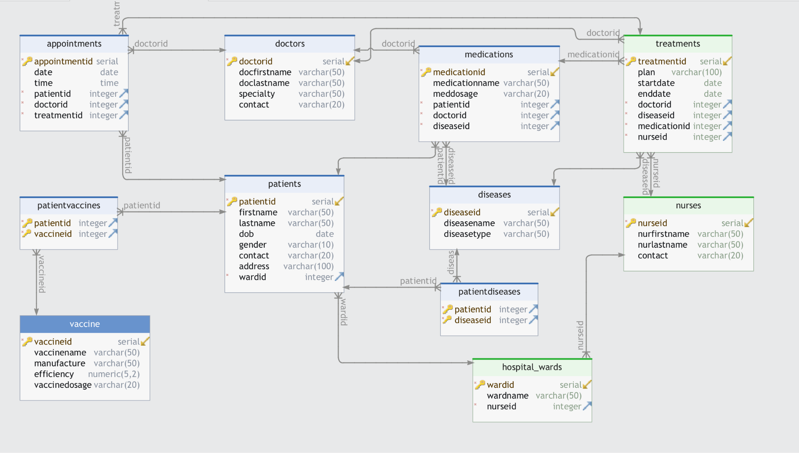

**Cardinalities:**

* Many Patients can have Many Diseases, and vice versa.
* Many Patients can receive Many Vaccines, and vice versa.
* One Doctor can be associated with Many Treatments, but each Treatment is associated with One Doctor.
* One Disease can be associated with Many Treatments, but each Treatment is associated with One Disease.
* One Medication can be associated with Many Treatments, but each Treatment is associated with One Medication.
* One Nurse can be associated with Many Treatments, but each Treatment is associated with One Nurse.
* One Patient can be assigned to One Hospital Ward, but each Hospital Ward can have Many Patients.
* One Patient can have Many Appointments.
* One Doctor can have Many Appointments.
* One Treatment can have Many Appointments.

**Data Dictionary:**

**Patients Table:**

|  |  |  |  |
| --- | --- | --- | --- |
| **Attribute** | **Description** | **Data Type** | **Constraint** |
| PatientID | Unique identifier for each patient | Integer | Primary Key, Not Null |
| FirstName | Patient's first name | Varchar(50) | Not Null |
| LastName | Patient's last name | Varchar(50) | Not Null |
| DOB | Patient's date of birth | Date | Not Null |
| Gender | Patient's gender | Varchar(10) | Not Null |
| Contact | Patient's contact information | Varchar(20) |  |
| Address | Patient's address | Varchar(100) |  |
| WardID | Identifier of the assigned ward | Integer | Foreign Key to Hospital_Wards(WardID), Not Null |

**Diseases Table:**

|  |  |  |  |
| --- | --- | --- | --- |
| **Attribute** | **Description** | **Data Type** | **Constraint** |
| DiseaseID | Unique identifier for each disease | Integer | Primary Key, Not Null |
| DiseaseName | Name of the disease | Varchar(50) | Not Null |
| DiseaseType | Type or category of the disease | Varchar(50) |  |

**Medications Table:**

|  |  |  |  |
| --- | --- | --- | --- |
| **Attribute** | **Description** | **Data Type** | **Constraint** |
| MedicationID | Unique identifier for each medication | Integer | Primary Key, Not Null |
| MedicationName | Name of the medication | Varchar(50) | Not Null |
| MedDosage | Dosage information for the medication | Varchar(20) |  |
| PatientID | Identifier of the patient for the medication | Integer | Foreign Key to Patients(PatientID), Not Null |
| DoctorID | Identifier of the doctor prescribing the medication | Integer | Foreign Key to Doctors(DoctorID), Not Null |
| DiseaseID | Identifier of the disease the medication treats | Integer | Foreign Key to Diseases(DiseaseID), Not Null |

**Vaccine Table:**

|  |  |  |  |
| --- | --- | --- | --- |
| **Attribute** | **Description** | **Data Type** | **Constraint** |
| VaccineID | Unique identifier for each vaccine | Integer | Primary Key, Not Null |
| VaccineName | Name of the vaccine | Varchar(50) | Not Null |
| Manufacture | Manufacturer of the vaccine | Varchar(50) |  |
| Efficiency | Efficiency of the vaccine (as a decimal) | Decimal(5,2) |  |
| VaccineDosage | Dosage information for the vaccine | Varchar(20) |  |

**Doctors Table:**

|  |  |  |  |
| --- | --- | --- | --- |
| **Attribute** | **Description** | **Data Type** | **Constraint** |
| DoctorID | Unique identifier for each doctor | Integer | Primary Key, Not Null |
| DocFirstName | Doctor's first name | Varchar(50) | Not Null |
| DocLastName | Doctor's last name | Varchar(50) | Not Null |
| Specialty | Doctor's specialty in medicine | Varchar(50) | Not Null |
| Contact | Doctor's contact information | Varchar(20) |  |

**Nurses Table:**

|  |  |  |  |
| --- | --- | --- | --- |
| **Attribute** | **Description** | **Data Type** | **Constraint** |
| NurseID | Unique identifier for each nurse | Integer | Primary Key, Not Null |
| NurFirstName | Nurse's first name | Varchar(50) | Not Null |
| NurLastName | Nurse's last name | Varchar(50) | Not Null |
| Contact | Nurse's contact information | Varchar(20) |  |

**Treatments Table:**

|  |  |  |  |
| --- | --- | --- | --- |
| **Attribute** | **Description** | **Data Type** | **Constraint** |
| TreatmentID | Unique identifier for each treatment | Integer | Primary Key, Not Null |
| Plan | Description of the treatment plan | Varchar(100) |  |
| StartDate | Start date of the treatment | Date |  |
| EndDate | End date of the treatment | Date |  |
| DoctorID | Identifier of the treating doctor | Integer | Foreign Key to Doctors(DoctorID), Not Null |
| DiseaseID | Identifier of the disease for the treatment | Integer | Foreign Key to Diseases(DiseaseID), Not Null |
| MedicationID | Identifier of the medication used in the treatment | Integer | Foreign Key to Medications(MedicationID), Not Null |
| NurseID | Identifier of the nurse involved in the treatment | Integer | Foreign Key to Nurses(NurseID), Not Null |

**Hospital_Wards Table:**

|  |  |  |  |
| --- | --- | --- | --- |
| **Attribute** | **Description** | **Data Type** | **Constraint** |
| WardID | Unique identifier for each hospital ward | Integer | Primary Key, Not Null |
| WardName | Name of the hospital ward | Varchar(50) | Not Null |
| NurseID | Identifier of the nurse in charge of the ward | Integer | Foreign Key to Nurses(NurseID), Not Null |

**Appointments Table:**

|  |  |  |  |
| --- | --- | --- | --- |
| **Attribute** | **Description** | **Data Type** | **Constraint** |
| AppointmentID | Unique identifier for each appointment | Integer | Primary Key, Not Null |
| Date | Date of the appointment | Date | Not Null |
| Time | Time of the appointment | Time | Not Null |
| PatientID | Identifier of the patient for the appointment | Integer | Foreign Key to Patients(PatientID), Not Null |
| DoctorID | Identifier of the doctor for the appointment | Integer | Foreign Key to Doctors(DoctorID), Not Null |
| TreatmentID | Identifier of the treatment for the appointment | Integer | Foreign Key to Treatments(TreatmentID), Not Null |

**PatientDiseases Table (for Many-to-Many Relationship):**

|  |  |  |  |
| --- | --- | --- | --- |
| **Attribute** | **Description** | **Data Type** | **Constraint** |
| PatientID | Identifier of the patient | Integer | Foreign Key to Patients(PatientID), Not Null |
| DiseaseID | Identifier of the disease | Integer | Foreign Key to Diseases(DiseaseID), Not Null |
|  |  |  | Primary Key (Composite) |

**PatientVaccines Table (for Many-to-Many Relationship):**

|  |  |  |  |
| --- | --- | --- | --- |
| **Attribute** | **Description** | **Data Type** | **Constraint** |
| PatientID | Identifier of the patient | Integer | Foreign Key to Patients(PatientID), Not Null |
| VaccineID | Identifier of the vaccine | Integer | Foreign Key to Vaccine(VaccineID), Not Null |
|  |  |  | Primary Key (Composite) |

Insert values into database :

-- Insert Query

INSERT INTO Nurses (NurFirstName, NurLastName, Contact)

VALUES

('Nurse Emily', 'Williams', '555-4321'),

('Nurse James', 'Brown', '555-8765'),

('Nurse Smith', 'Miller', '111-222-3333'),

('Nurse Davis', 'Wilson', '444-555-6666'),

('Nurse Taylor', 'Johnson', '777-888-9999'),

('Nurse Brown', 'Clark', '333-777-5555'),

('Nurse Robinson', 'Lee', '555-999-1111');

INSERT INTO Hospital_Wards (WardName, NurseID)

VALUES

('Cardiology Ward', 1),

('Pediatrics Ward', 2);

select * from Hospital_Wards;

INSERT INTO Patients (FirstName, LastName, DOB, Gender, Contact, Address, WardID)

VALUES

('Emma', 'Doe', '1990-05-15', 'Male', '201-456-7890', '123 Main St, Cityville', 1),

('Jemmy', 'Smith', '1985-08-22', 'Female', '987-654-3210', '456 Oak St, Townsville', 2),

('Celeb', 'Brown', '1995-08-20', 'F', '555-111-2222', '342 Oak St, Townsville', 2),

('Bob', 'Smith', '1980-03-12', 'M', '444-333-5555', '789 Maple Ave, Townsville', 1),

('Catherine', 'Davis', '2000-11-05', 'F', '777-888-9999', '123 Pine Rd, Columbia', 2),

('Lucas', 'Miller', '1975-06-30', 'M', '222-666-4444', '101 Cedar Ln, Townsville', 2),

('Harpar', 'Taylor', '1992-09-15', 'F', '888-777-5555', '222 Birch Blvd, New jersey', 1);

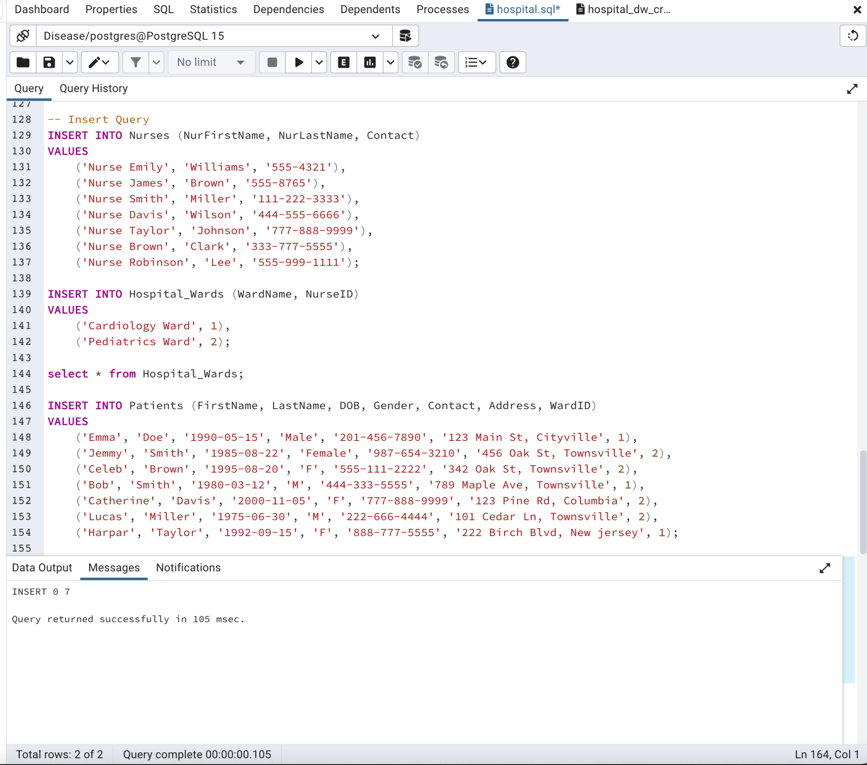

INSERT INTO Diseases (DiseaseName, DiseaseType)

VALUES

('Influenza', 'Viral'),

('Diabetes', 'Metabolic'),

('Hypertension', 'Cardiovascular'),

('Diabetes', 'Metabolic'),

('Migraine', 'Neurological'),

('Allergy', 'Immunological');

INSERT INTO Vaccine (VaccineName, Manufacture, Efficiency, VaccineDosage)

VALUES

('COVID-19 Vaccine', 'PharmaCorp', 0.95, '2 doses'),

('Flu Vaccine', 'HealthCare Ltd', 0.90, '1 dose'),

('Hepatitis B Vaccine', 'BioPharma', 0.88, '3 doses'),

('COVID-19 Vaccine', 'Pfizer', 0.95, '1 doses'),

('Flu Vaccine', 'Sanofi', 0.92, '1 doses'),

('HPV Vaccine', 'Merck', 0.94, '1 doses'),

('Hepatitis B Vaccine', 'GSK', 0.95, '1 doses'),

('MMR Vaccine', 'Mylan', 0.95, '1 doses');

INSERT INTO Doctors (DocFirstName, DocLastName, Specialty, Contact)

VALUES

('Dr. Sarah', 'Johnson', 'Cardiology', '555-1234'),

('Dr.Michael', 'Smith', 'Pediatrics', '555-5678'),

('Dr. Patel', 'Jones', 'Internal Medicine', '555-999-1111'),

('Dr. Lee', 'Williams', 'Oncology', '888-444-3333'),

('Dr. Brown', 'Taylor', 'Pediatrics', '333-777-5555'),

('Dr. Wilson', 'Clark', 'Dermatology', '444-666-8888'),

('Dr. Robinson', 'Anderson', 'Orthopedics', '222-555-7777');

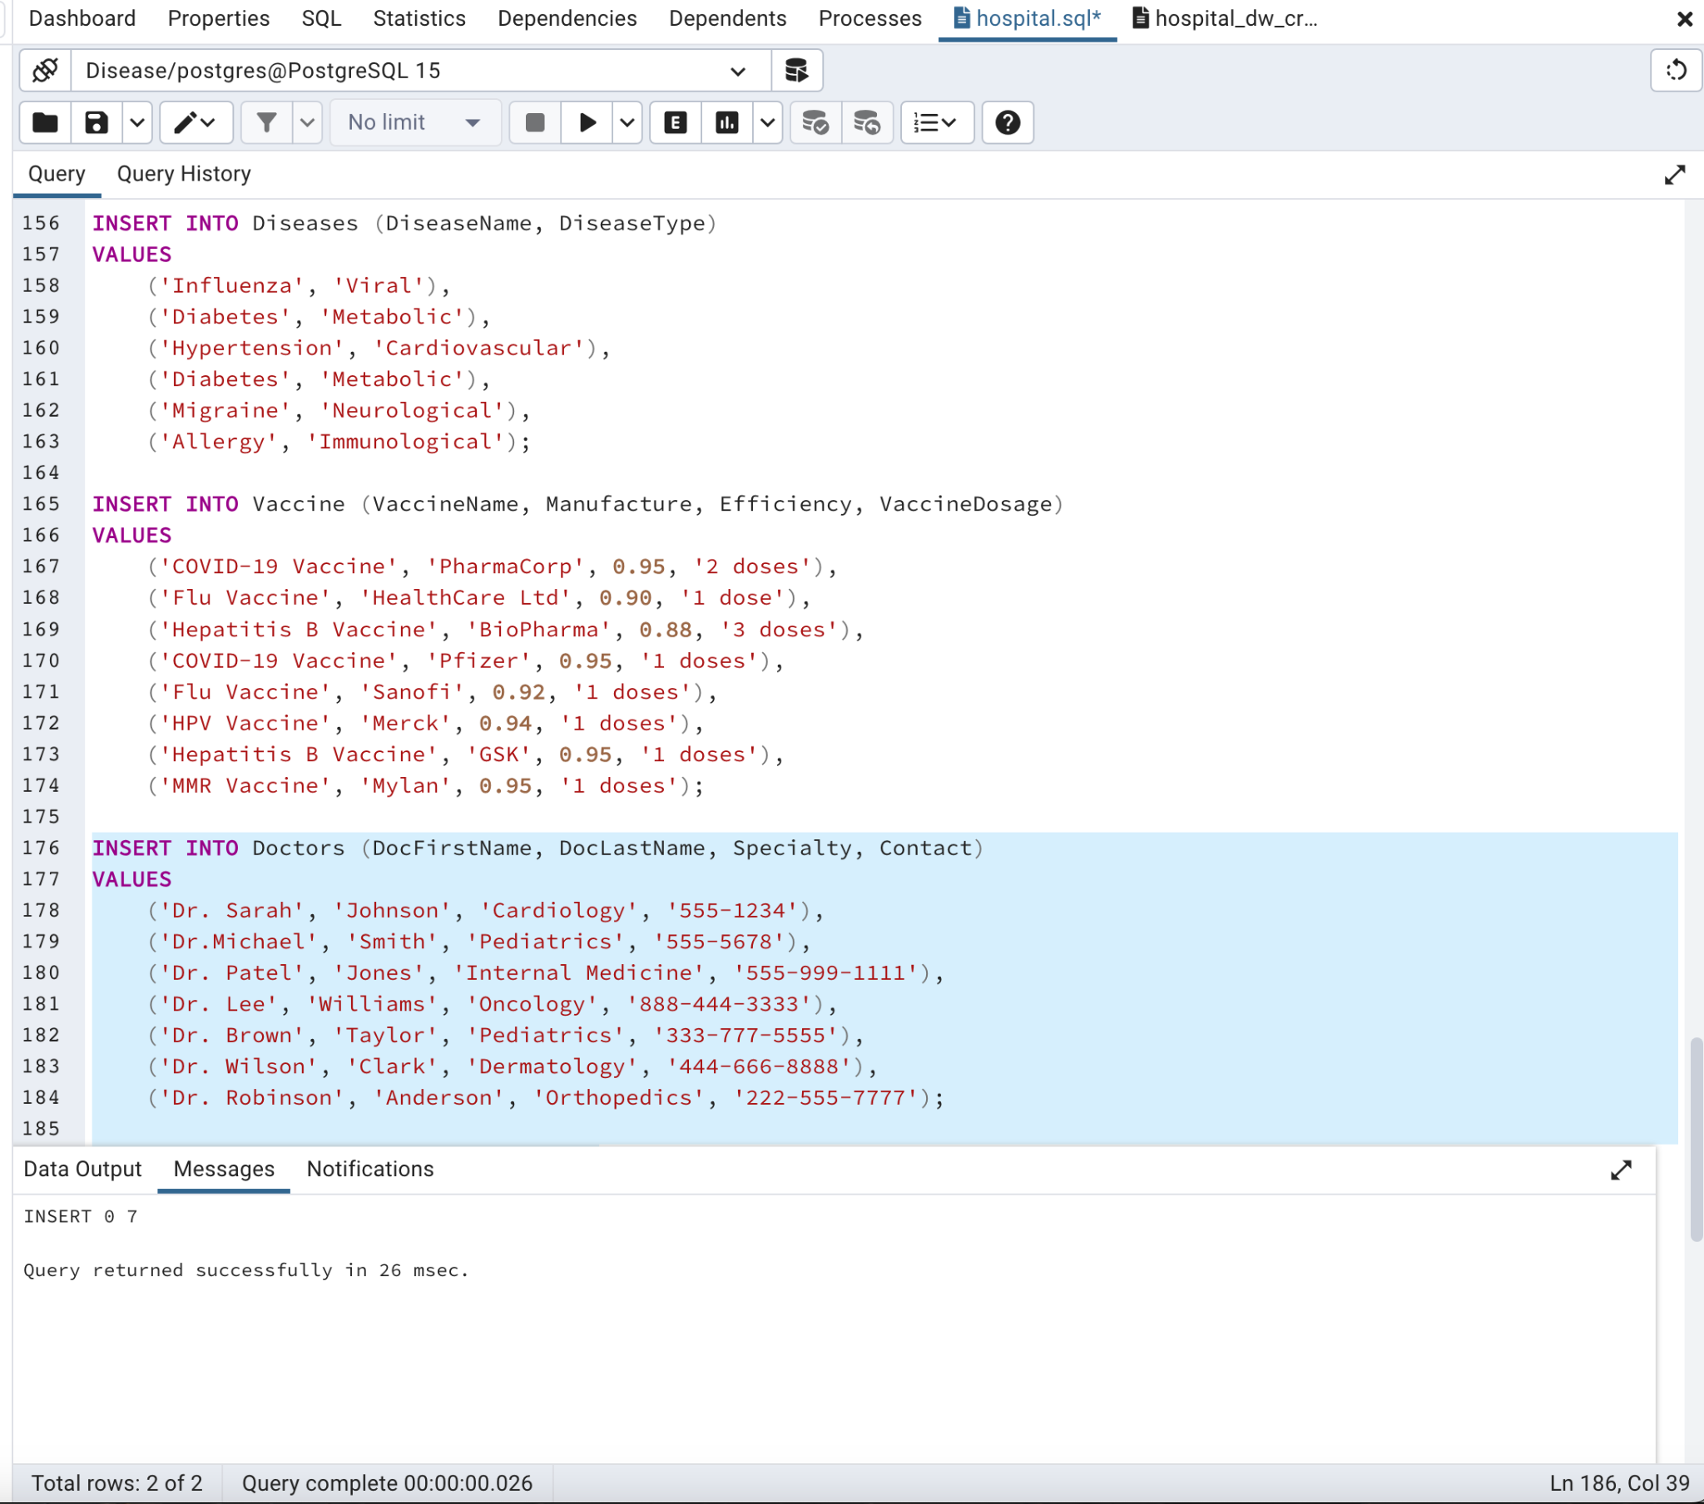

-- Assuming PatientID 7 and 8 corresponds to a specific patient

INSERT INTO Medications (MedicationName, MedDosage, PatientID, DoctorID, DiseaseID)

VALUES

('Aspirin', '100mg', 3, 1, 4),

('Insulin', '10 units', 4, 2, 6),

('Lisinopril', '2 units', 5, 3, 1),

('Insulin', '10 units', 1, 4, 5),

('Sumatriptan', '10 units', 2, 5, 2),

('Claritin', '10 units', 6, 6, 3);

SELECT * FROM Treatments;

INSERT INTO Treatments (Plan, StartDate, EndDate, DoctorID, DiseaseID, MedicationID, NurseID)

VALUES

('Rehabilitation', '2023-01-10', '2023-02-28', 1, 6, 4, 1),

('Diabetes Management', '2023-03-05', '2023-04-30', 2, 5, 2, 2),

('Physical Therapy', '2023-02-15', '2023-03-15', 3, 4, 1, 3),

('Allergy Testing', '2023-04-01', '2023-04-30', 6, 3, 6, 4),

('Cardiac Monitoring', '2023-05-10', '2023-06-10', 4, 2, 2, 6),

('Orthopedic Surgery', '2023-03-15', '2023-04-15', 5, 3, 2, 7),

('Neurological Assessment', '2023-04-20', '2023-05-20', 7, 4, 4, 5);

INSERT INTO Appointments (Date, Time, PatientID, DoctorID, TreatmentID)

VALUES

('2023-01-20', '10:00:00', 1, 4, 8),

('2023-03-15', '14:30:00', 2, 3, 9),

('2022-01-10', '10:00:00', 3, 4, 9),

('2022-01-15', '14:30:00', 4, 2, 8),

('2022-02-01', '09:45:00', 5, 7, 10),

('2022-02-10', '11:15:00', 6, 6, 11),

('2022-03-05', '16:00:00', 1, 5, 8);

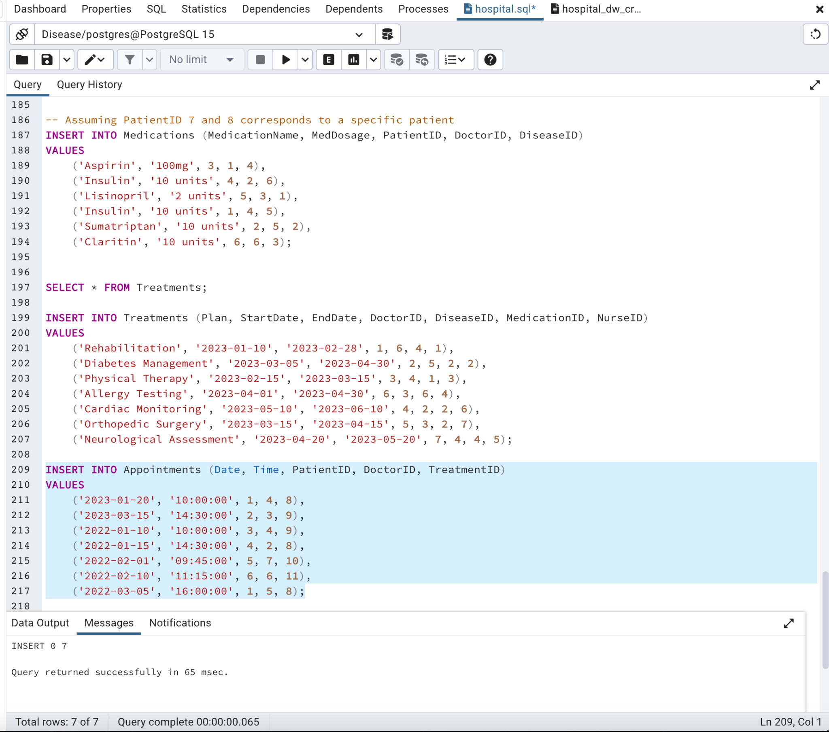

INSERT INTO PatientDiseases (PatientID, DiseaseID)

VALUES

(1, 1),

(1, 3),

(1, 2),

(2, 3),

(3, 3),

(3, 4),

(4, 5),

(5, 4),

(6, 4),

(6, 5),

(6, 2),

(7, 6);

INSERT INTO PatientVaccines (PatientID, VaccineID)

VALUES

(6, 1),

(5, 2),

(5, 3),

(1, 1),

(1, 5),

(4, 2),

(4, 3),

(3, 3),

(3, 5),

(4, 5),

(5, 4),

(6, 4),

(6, 5),

(6, 7),

(7, 6);

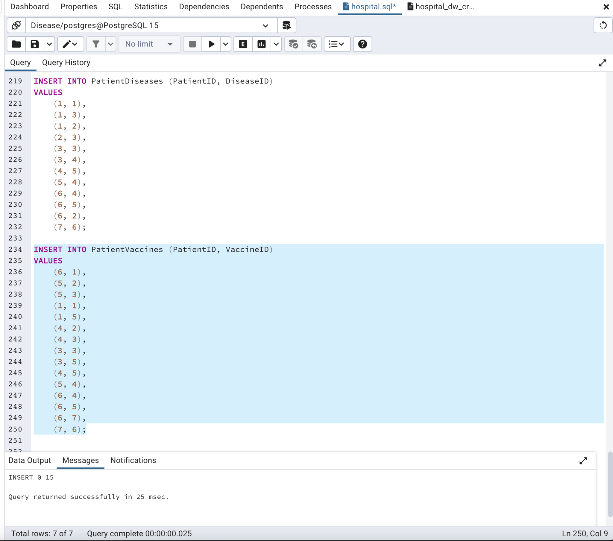

**Show appointments with patient details:**

SELECT Appointments.Date, Appointments.Time, Patients.FirstName, Patients.LastName, Doctors.DocFirstName, Doctors.DocLastName

FROM Appointments

JOIN Patients ON Appointments.PatientID = Patients.PatientID

JOIN Doctors ON Appointments.DoctorID = Doctors.DoctorID;

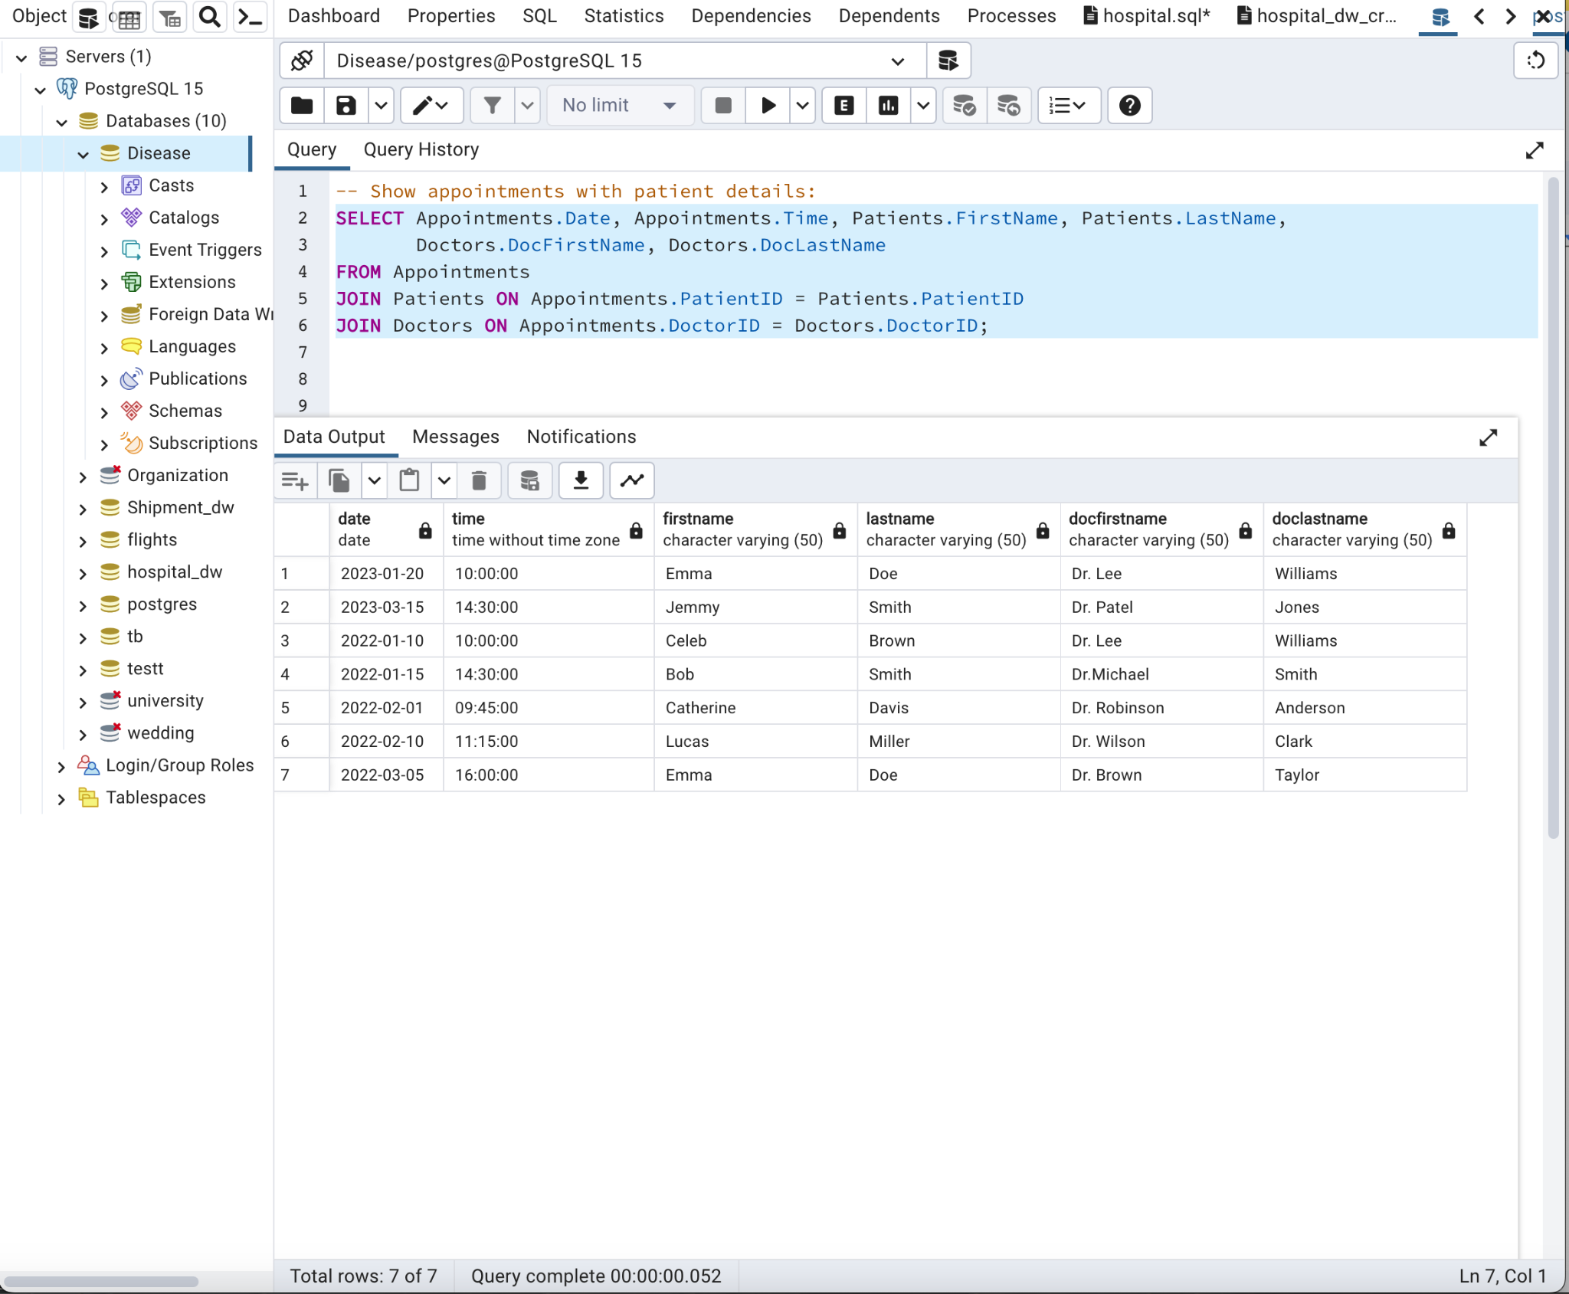

**Display treatments with associated medications:**

SELECT Treatments.Plan, Medications.MedicationName

FROM Treatments

JOIN Medications ON Treatments.MedicationID = Medications.MedicationID;

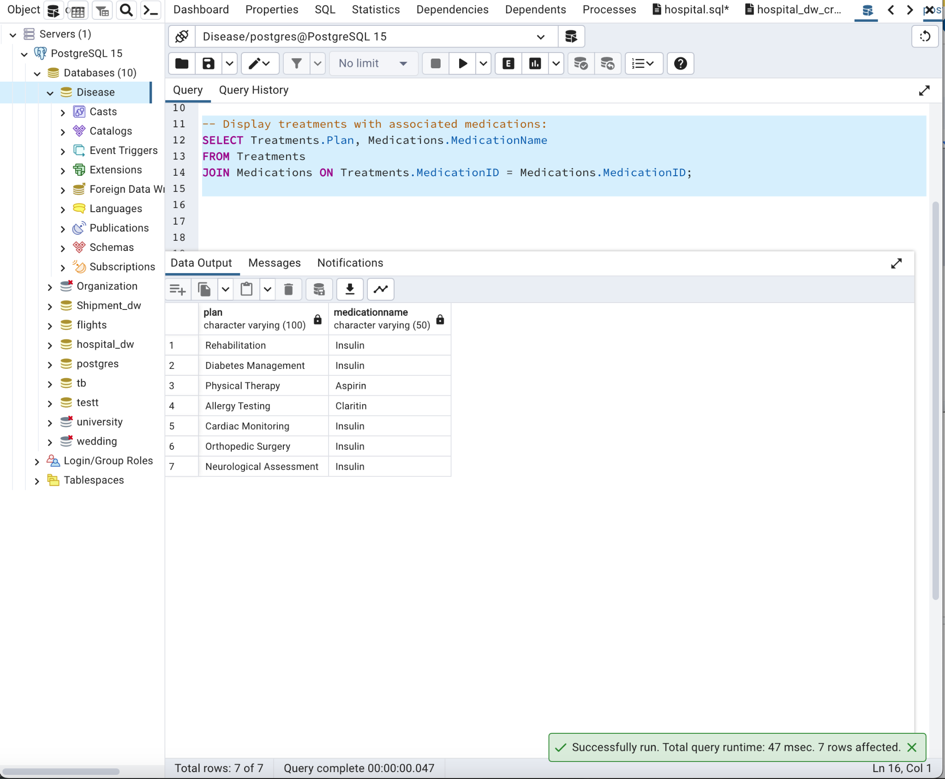

**-- Reports:**

-- **Count patients in each ward:**

SELECT Hospital_Wards.WardName, COUNT(Patients.PatientID) AS PatientCount

FROM Hospital_Wards

LEFT JOIN Patients ON Hospital_Wards.WardID = Patients.WardID

GROUP BY Hospital_Wards.WardName;

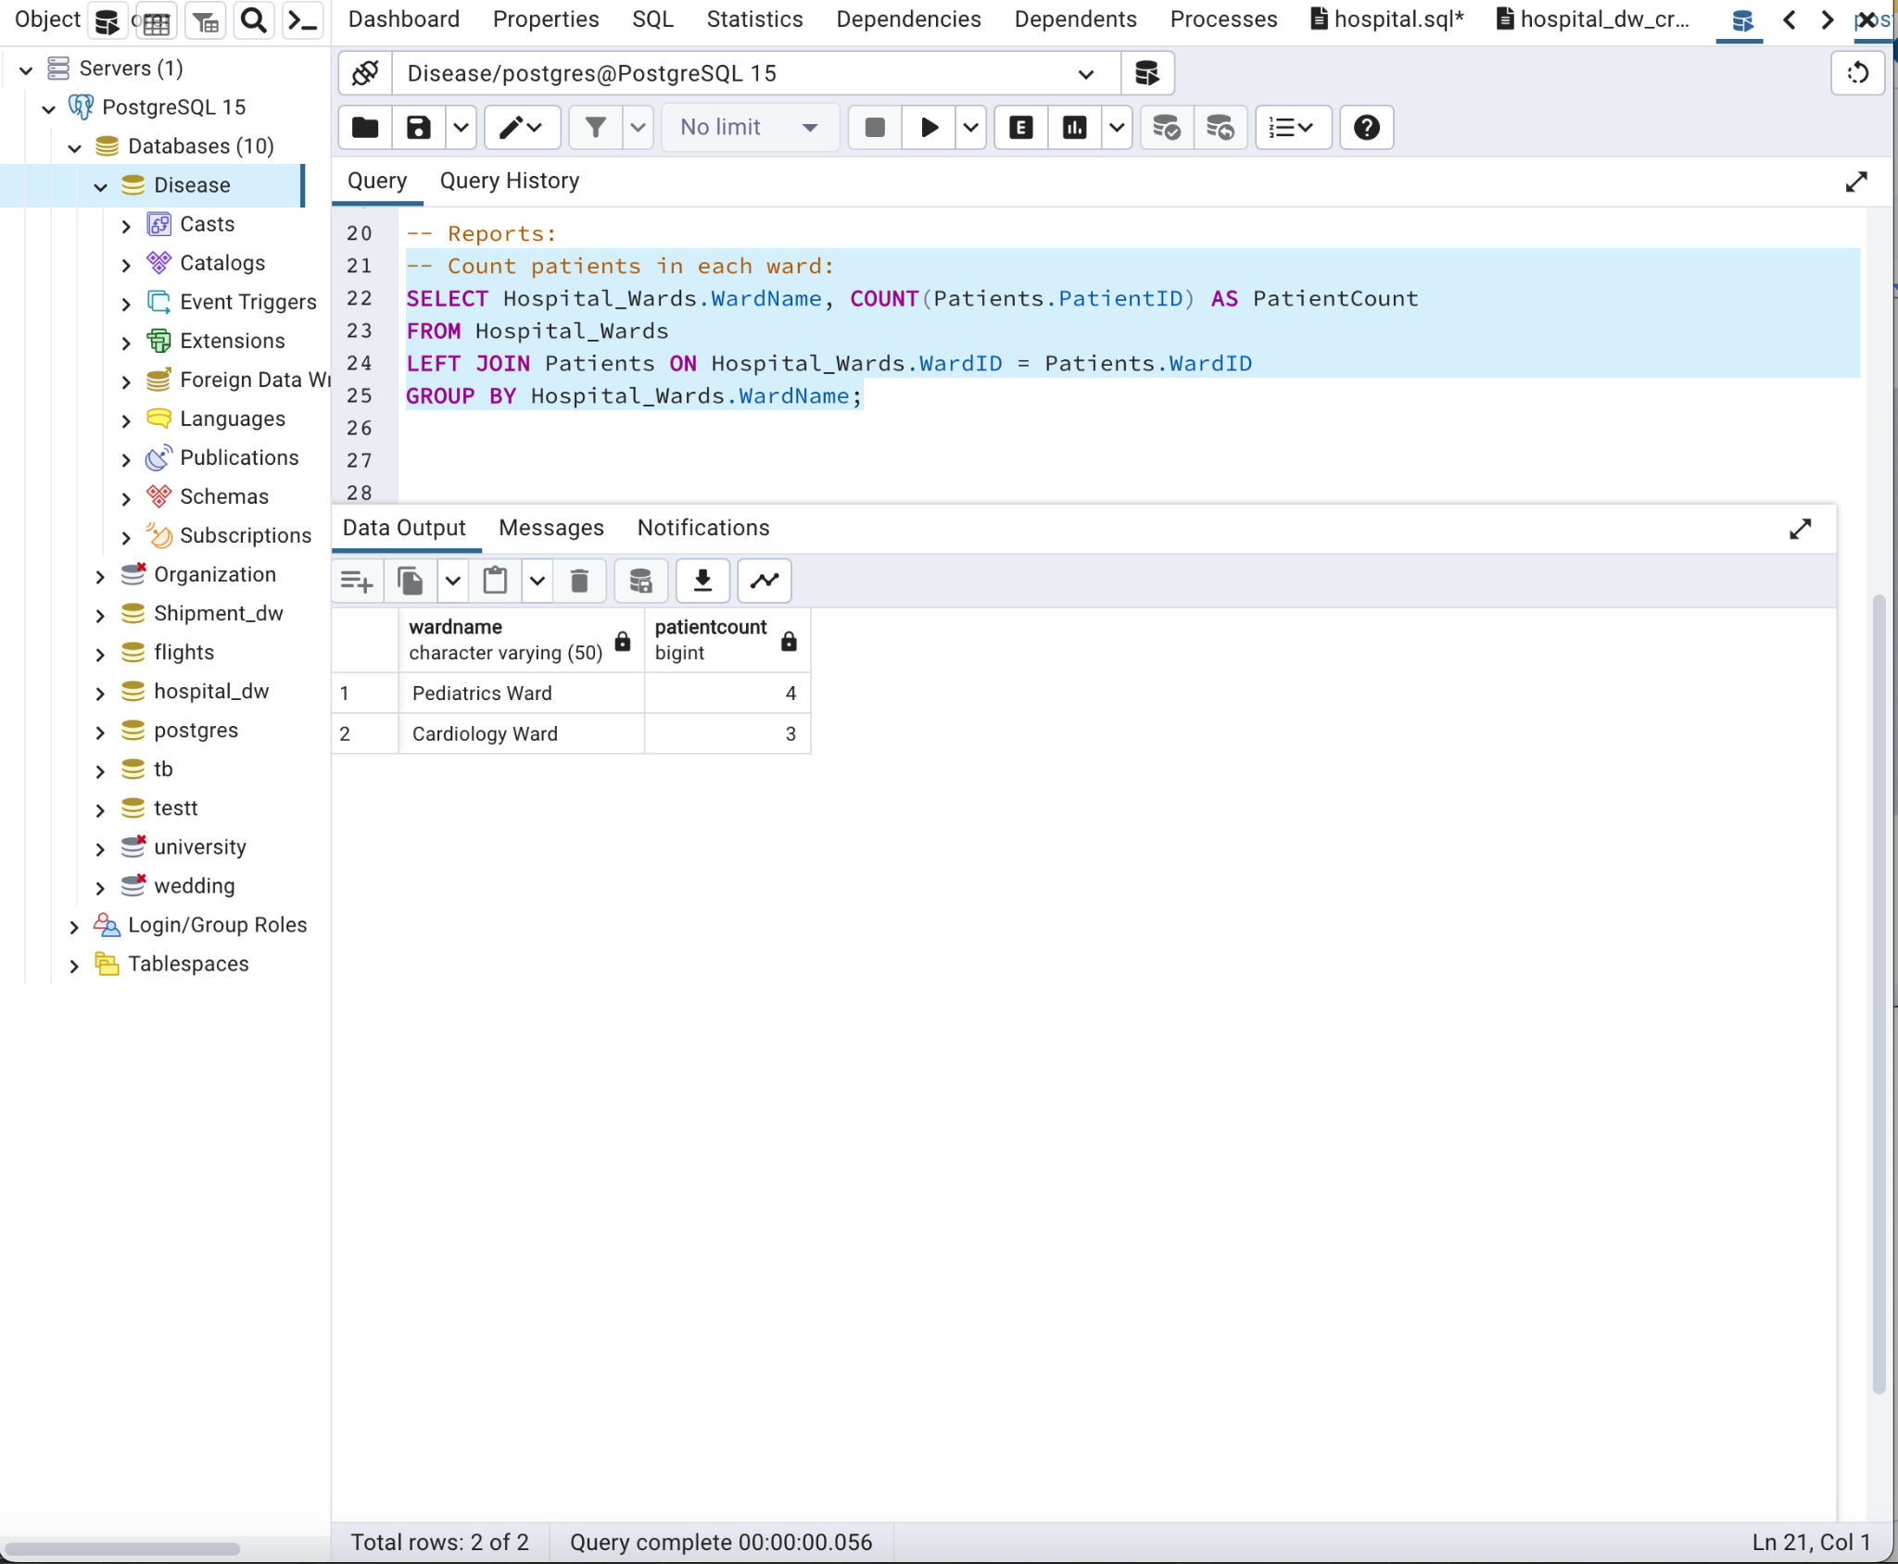

--**List patients with their diseases and medications:**

SELECT Patients.FirstName, Patients.LastName, Diseases.DiseaseName, Medications.MedicationName

FROM Patients

LEFT JOIN PatientDiseases ON Patients.PatientID = PatientDiseases.PatientID

LEFT JOIN Diseases ON PatientDiseases.DiseaseID = Diseases.DiseaseID

LEFT JOIN Medications ON Patients.PatientID = Medications.PatientID;

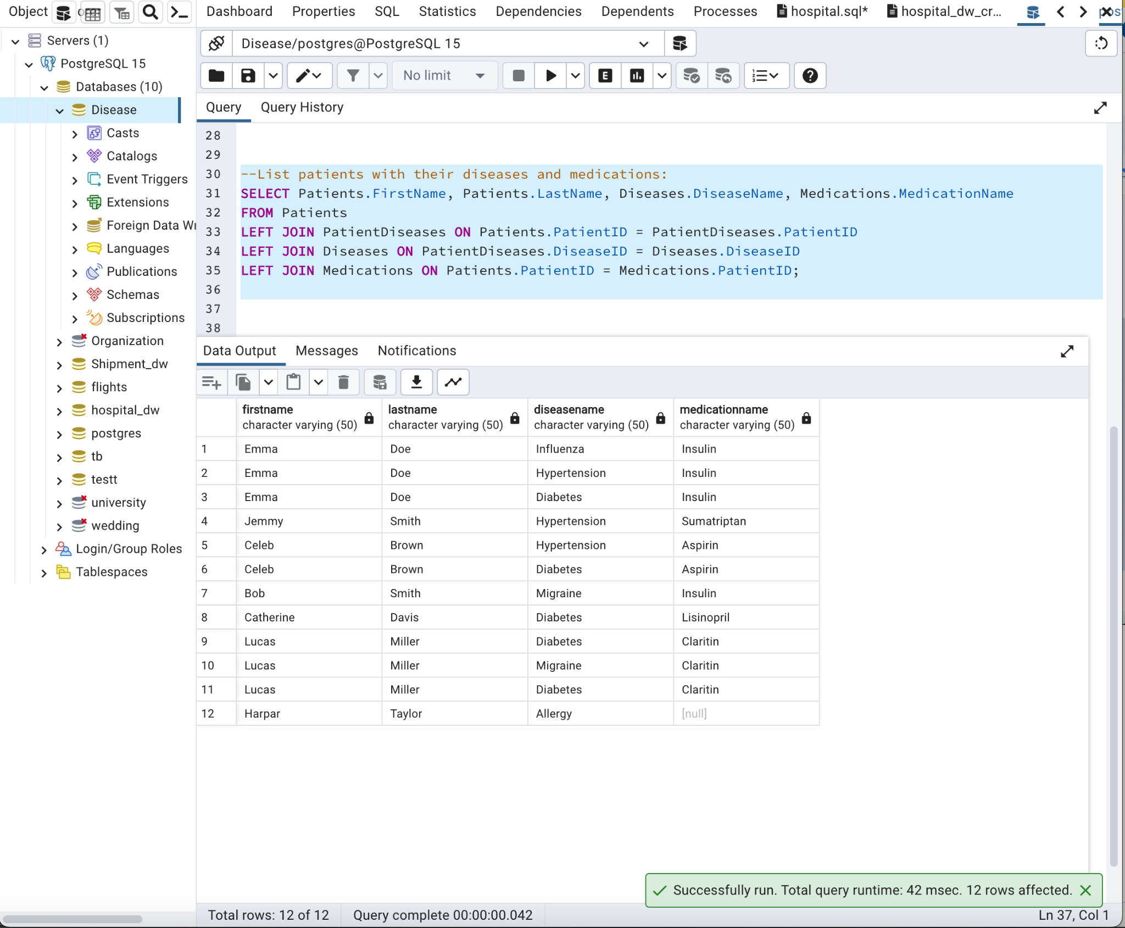

--Calculate efficiency of vaccines:

SELECT Vaccine.VaccineName, AVG(Vaccine.Efficiency) AS AverageEfficiency

FROM Vaccine

GROUP BY Vaccine.VaccineName;

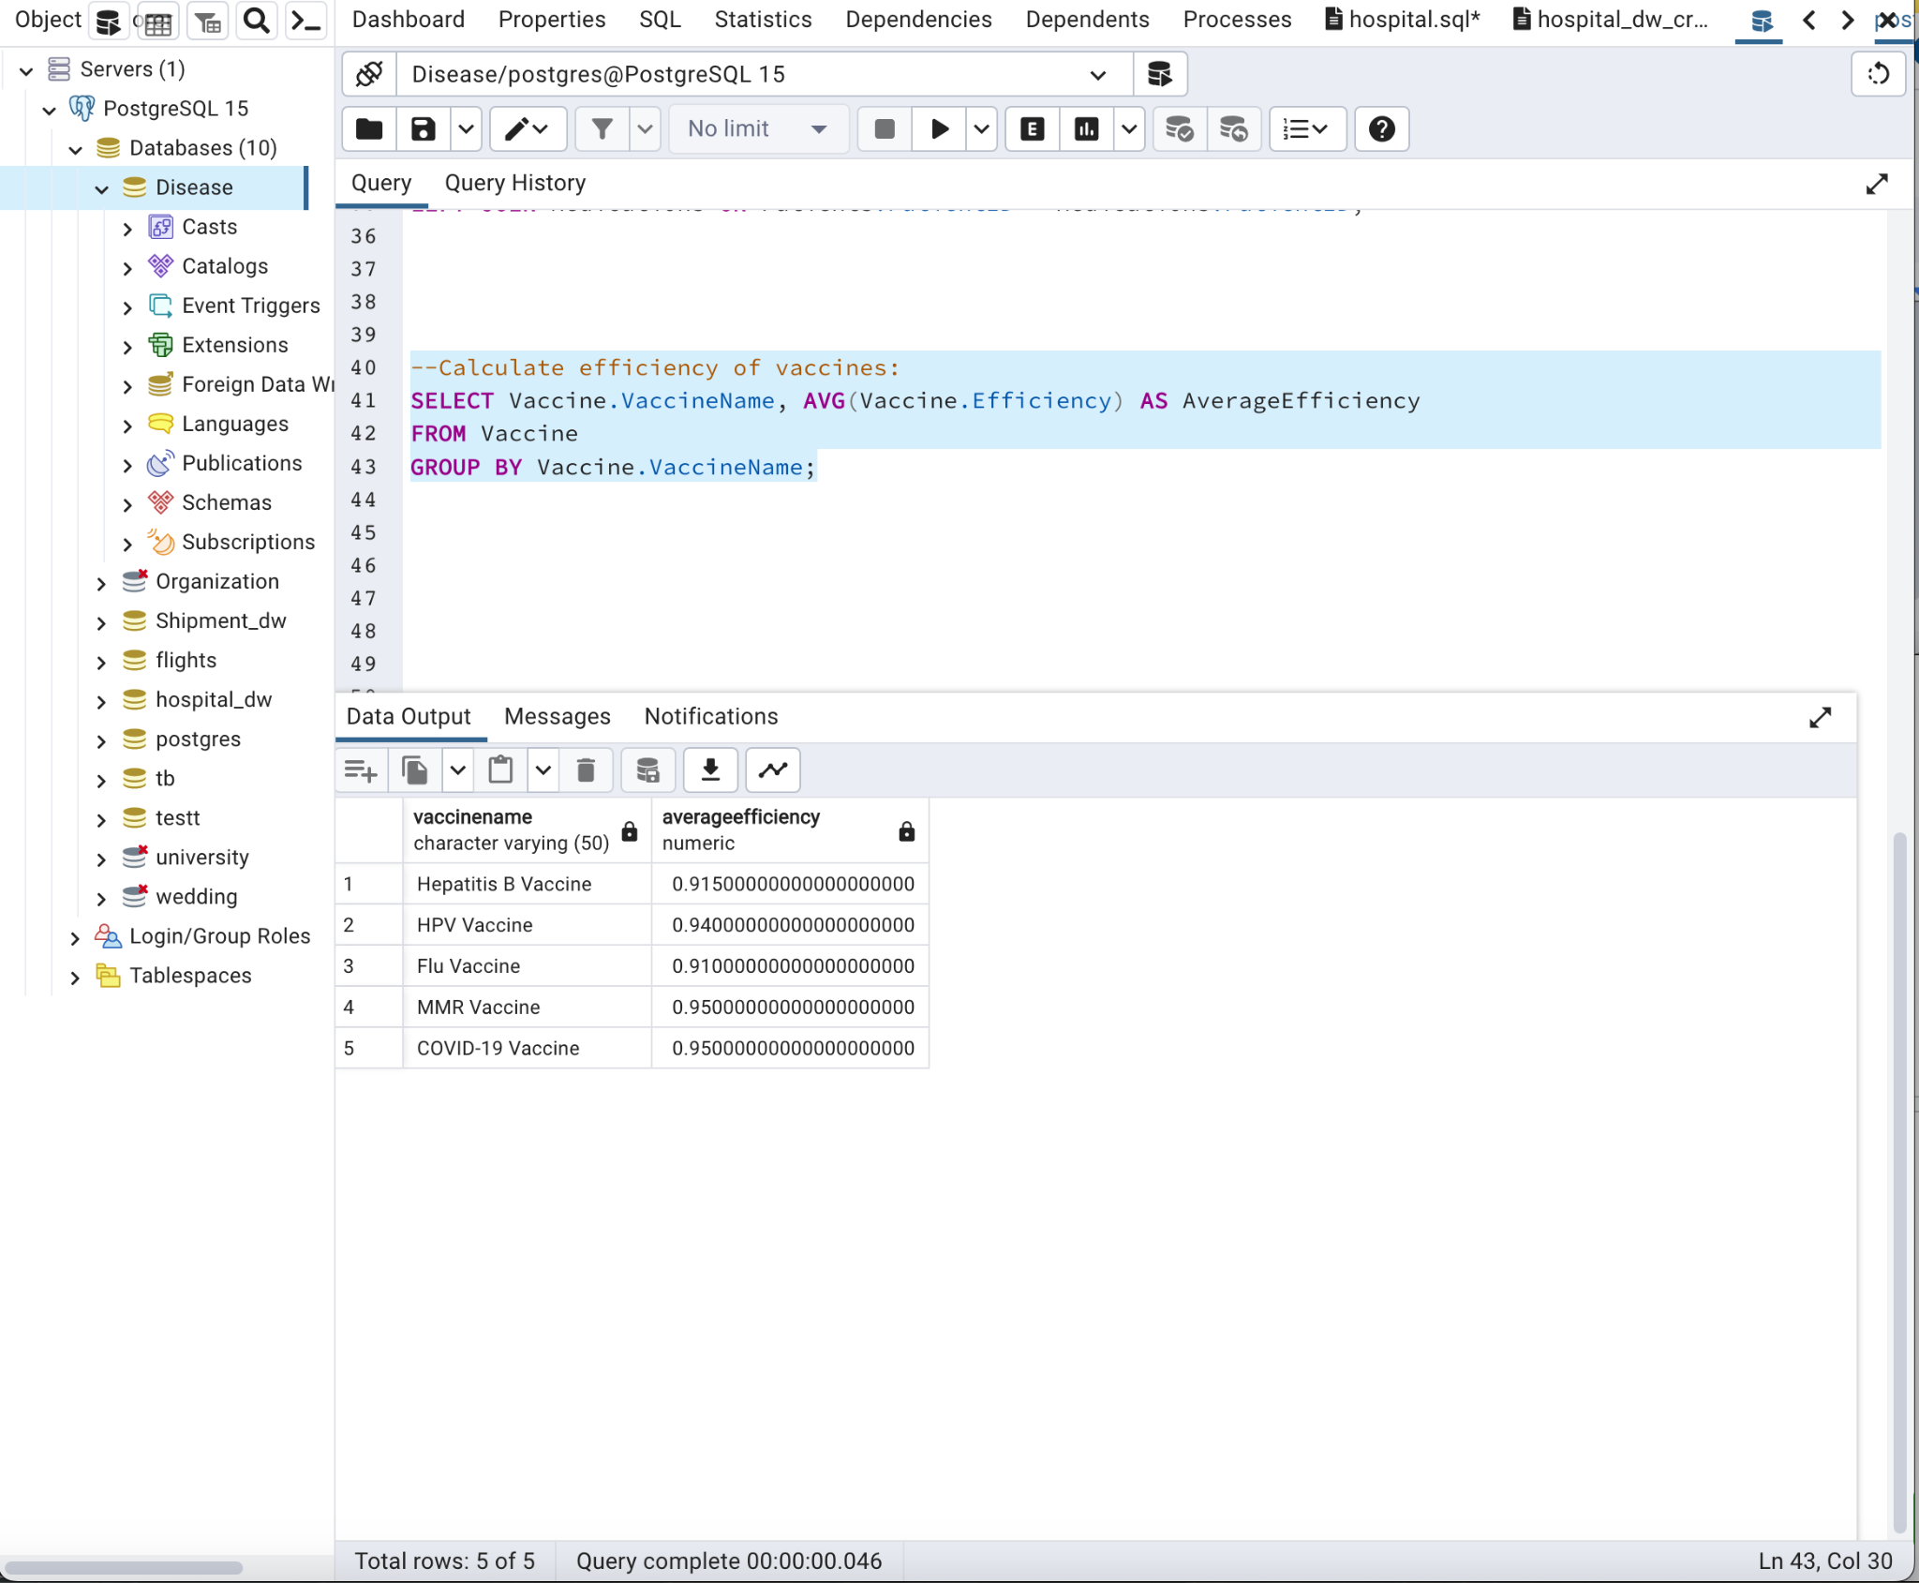

-- DML Operations:

--Update a patient's contact information:

UPDATE Patients

SET Contact = '555-9876'

WHERE PatientID = 1;

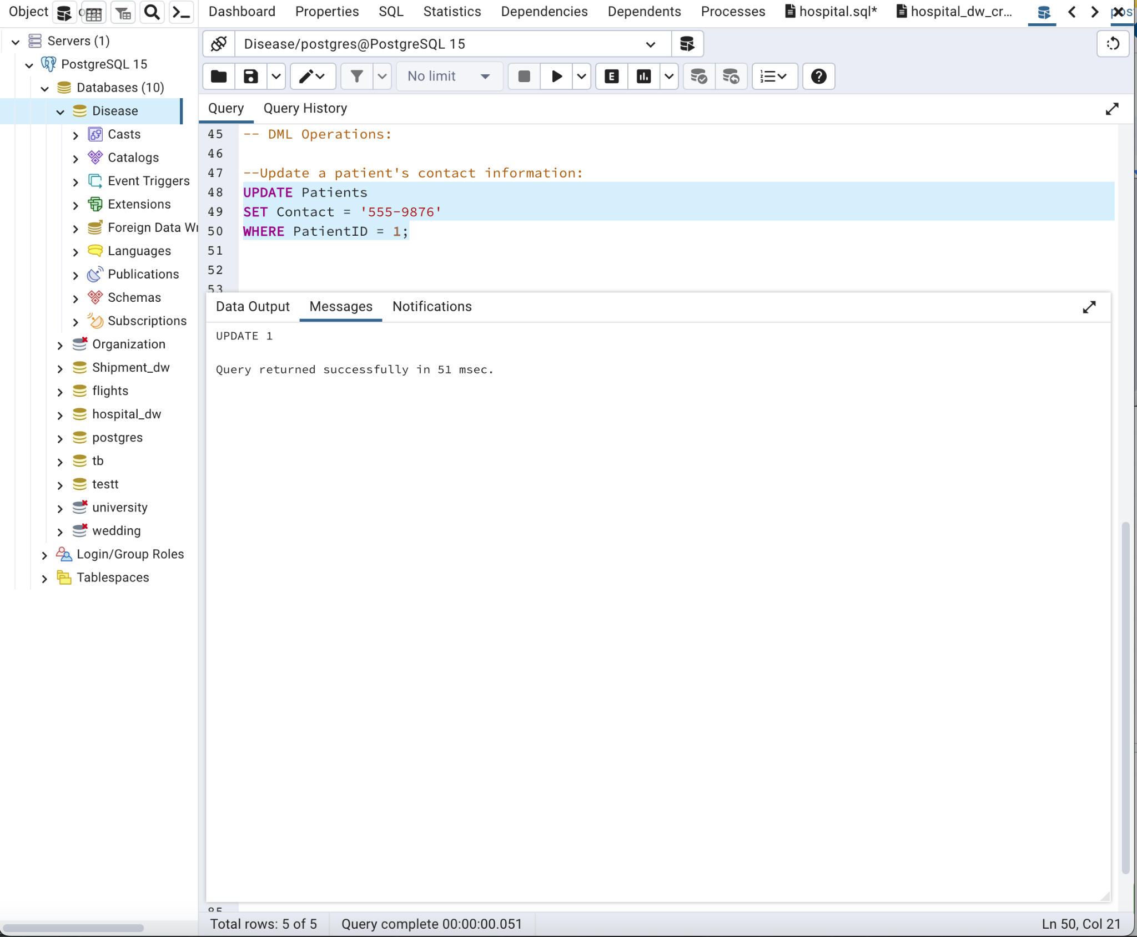

-- Insert a new patient:

INSERT INTO Patients (FirstName, LastName, DOB, Gender, Contact, Address, WardID)

VALUES ('Alex', 'Johnson', '1998-08-10', 'M', '777-111-2222', '789 Oak St', 2);

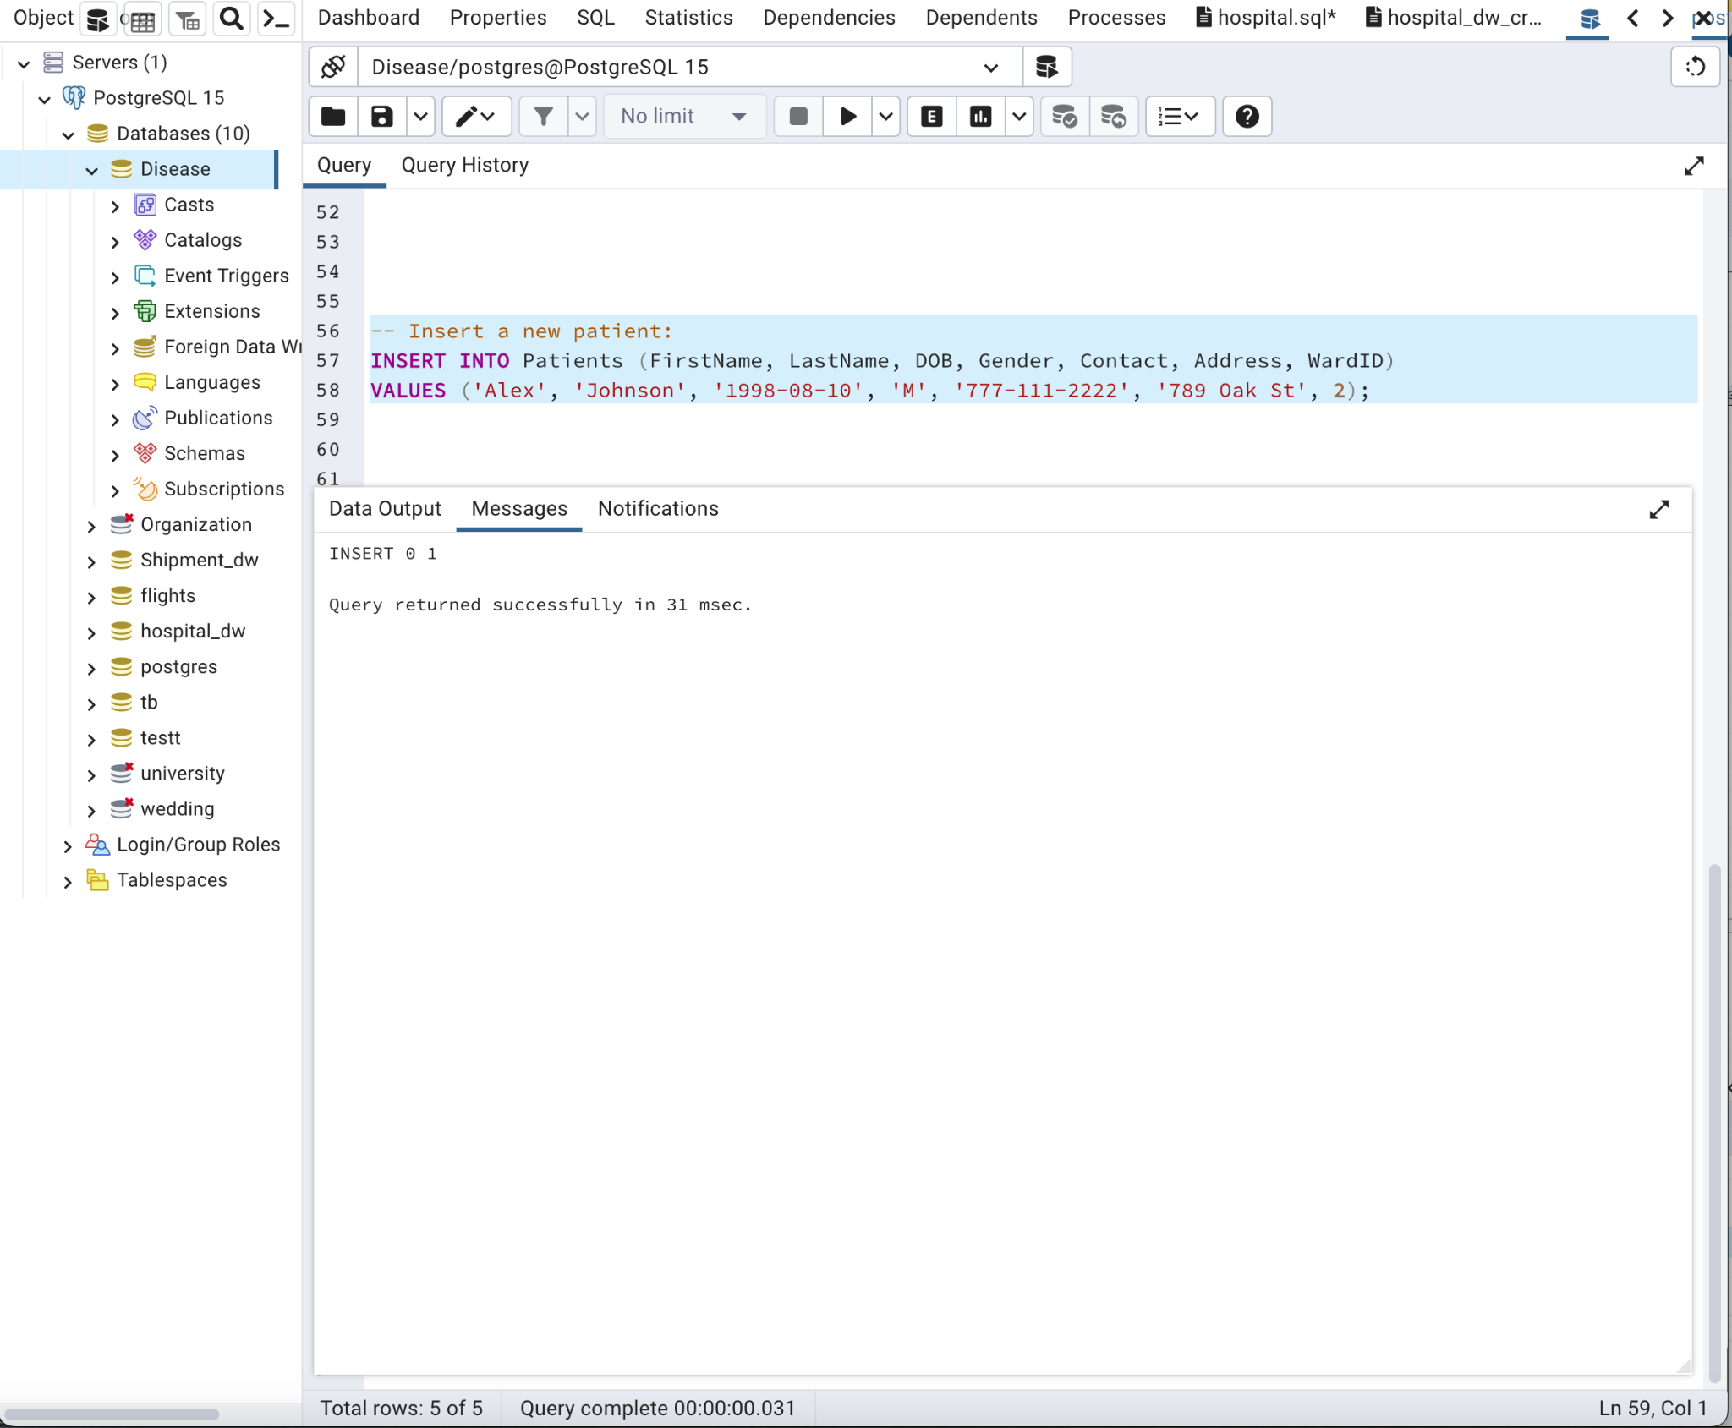

-- Delete a nurseid = 3 and reassign the ward:

-- 1st Update the treatments table to remove the reference to nurse with NurseID 3

UPDATE Treatments

SET NurseID = 4

WHERE NurseID = 3;

-- Now you can safely update or delete the nurse record

DELETE FROM Nurses

WHERE NurseID = 3;

UPDATE Hospital_Wards

SET NurseID = NULL

WHERE NurseID = 3;

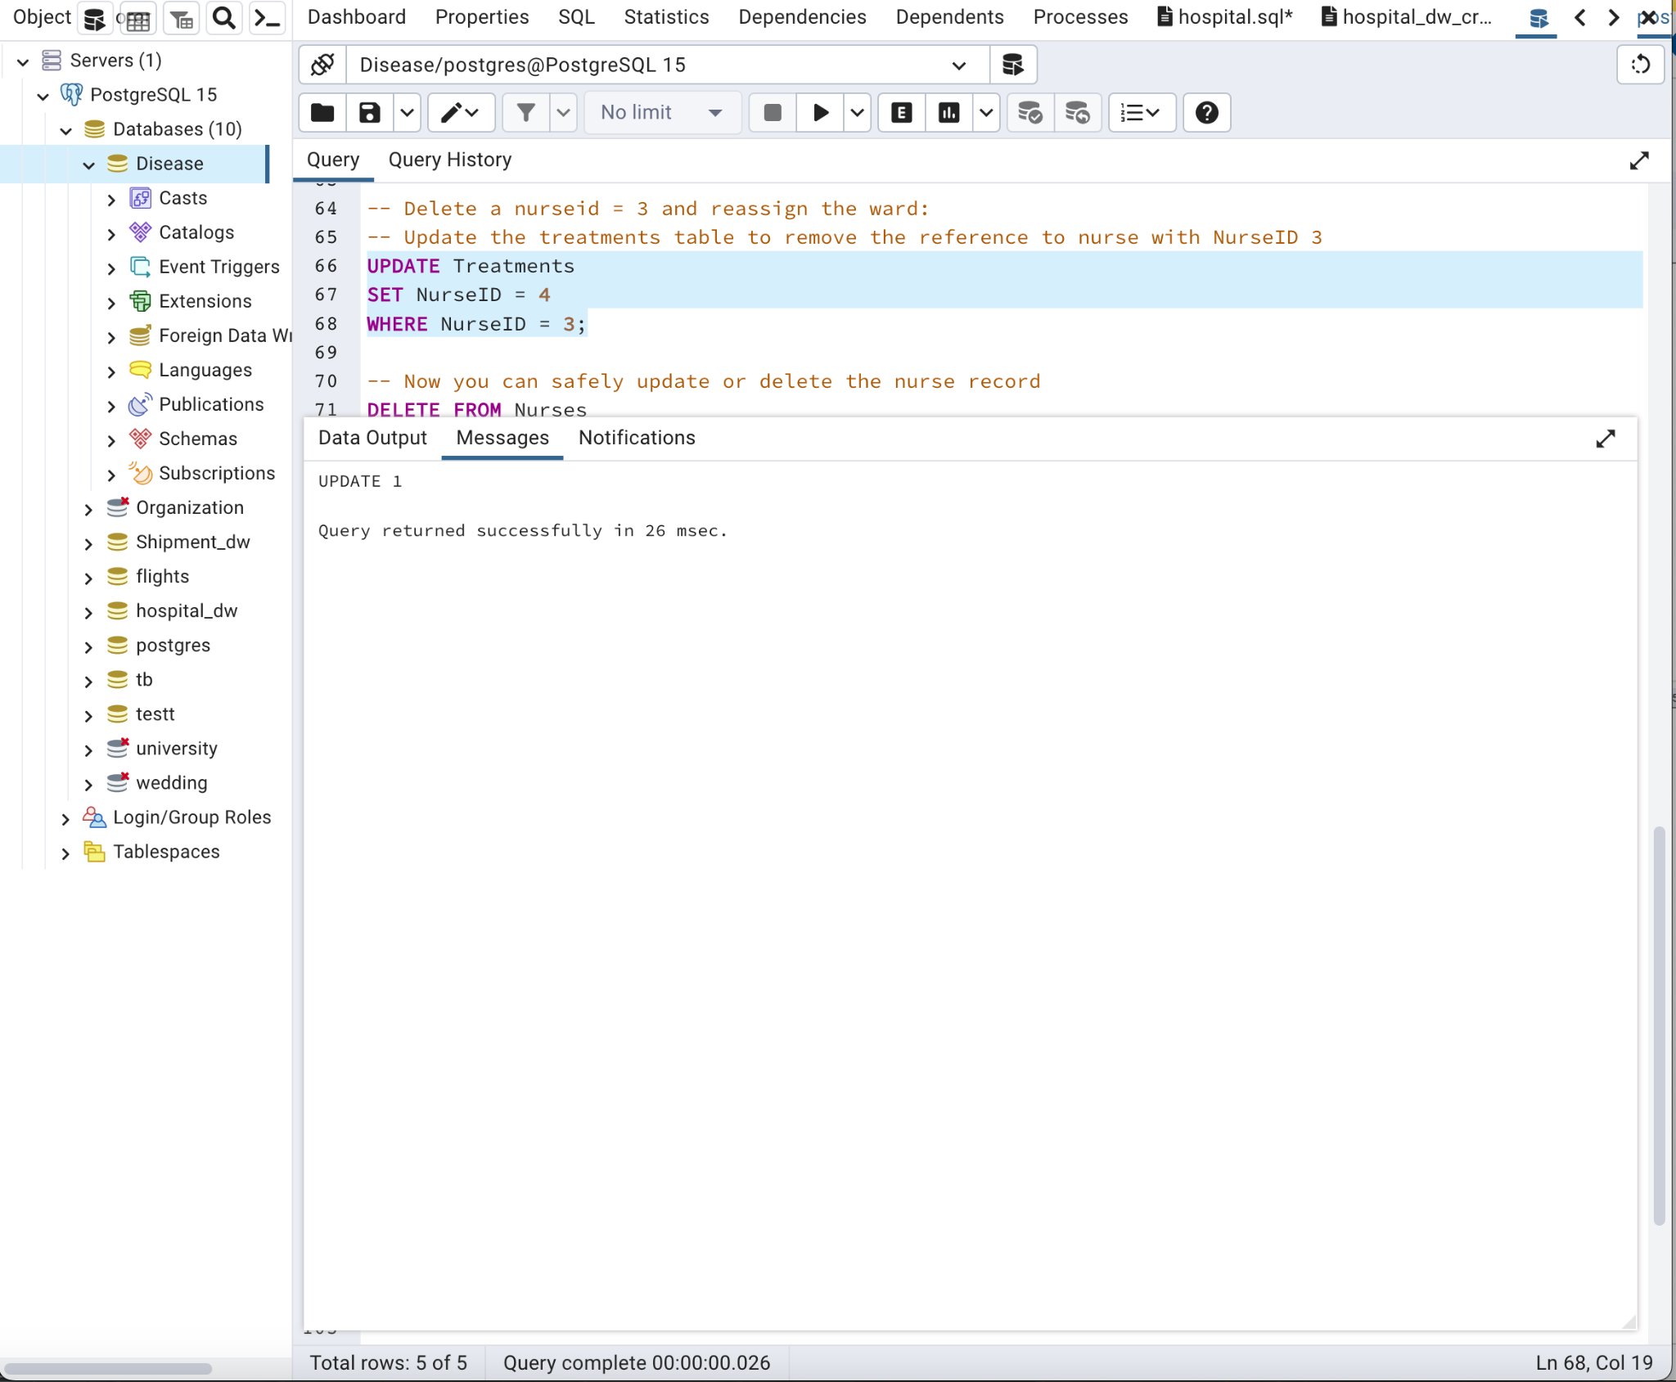

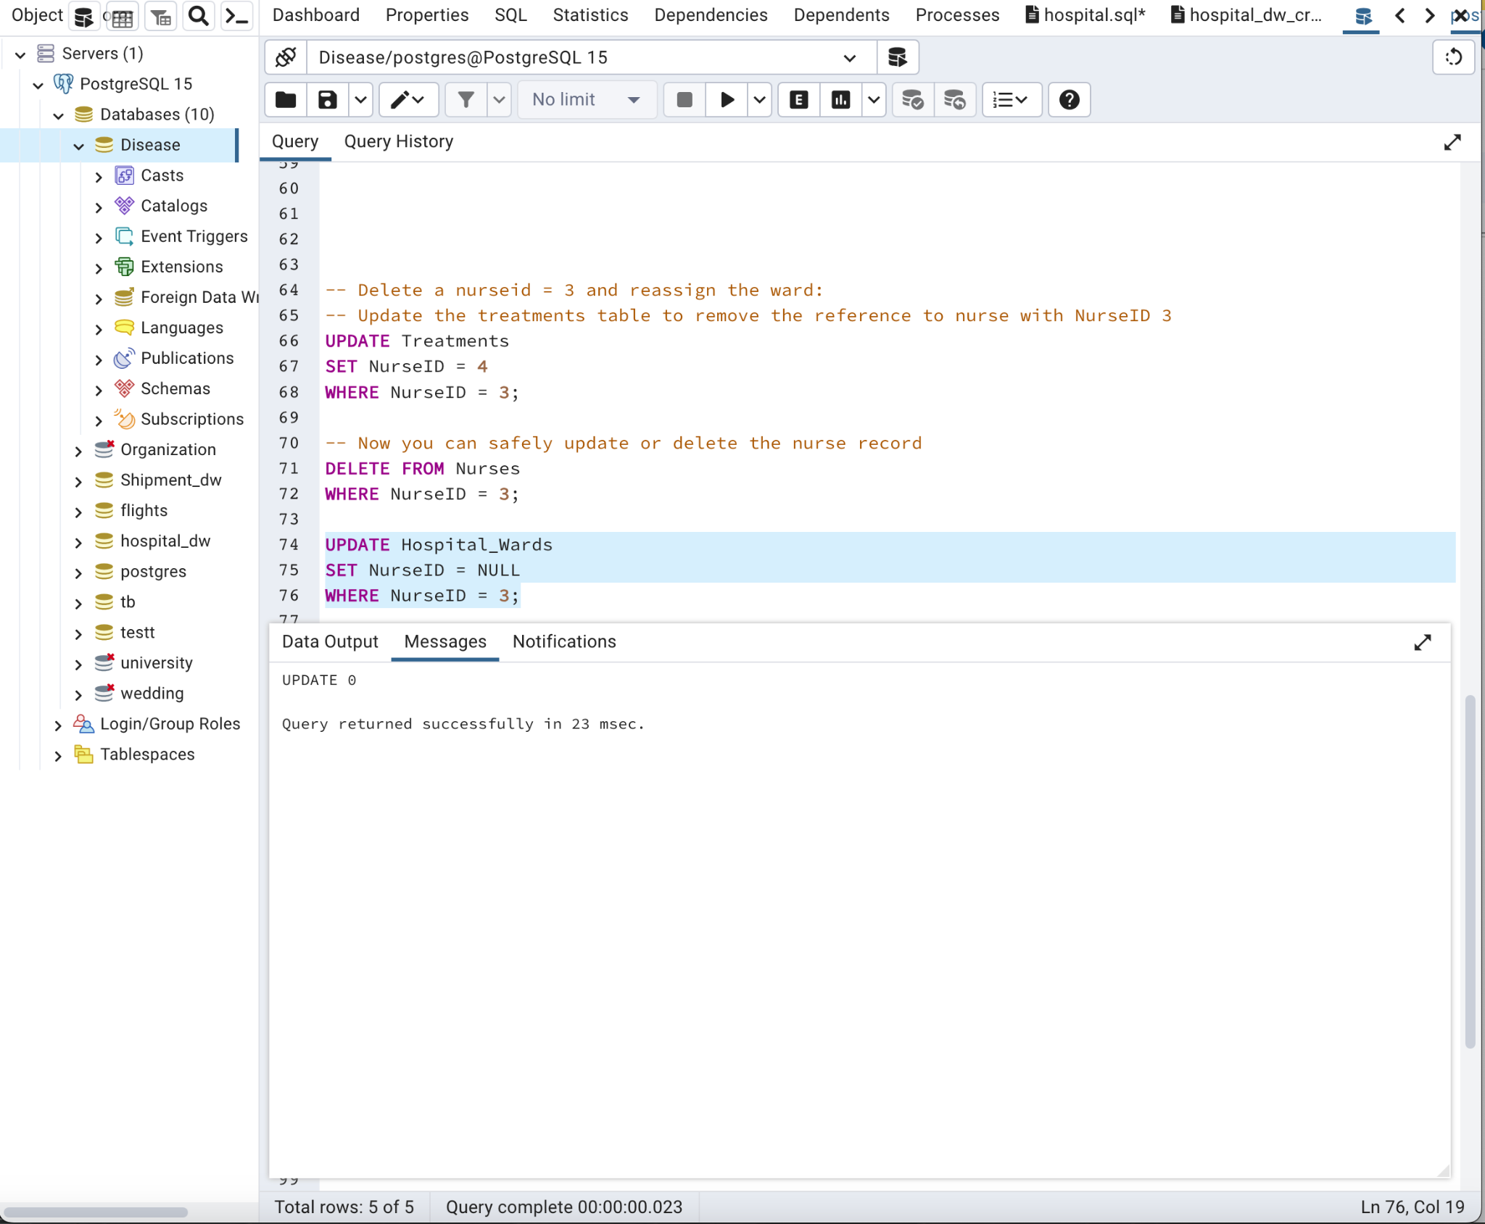

DIMENSIONAL MODEL :

**Created by clicking on schema in Disease Database**

-- Create a new schema for the dimensional model

CREATE SCHEMA disease_dw;

-- Set the search path to include the new schema

SET search_path TO disease_dw, public;

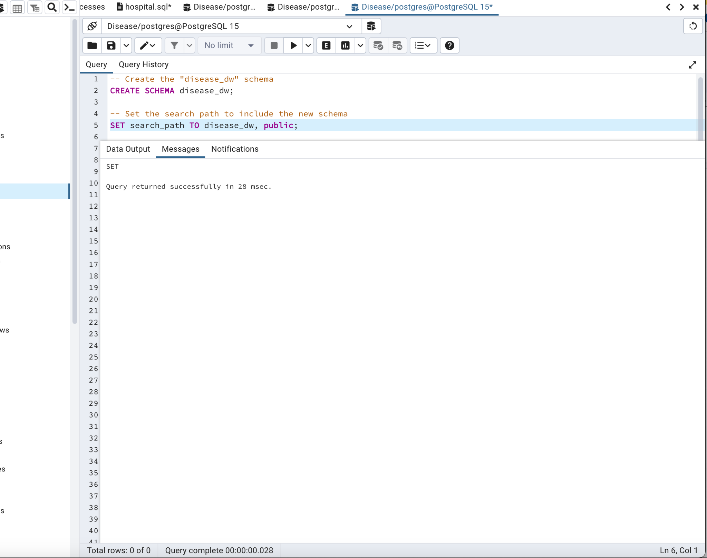

-- Create dimension tables

CREATE TABLE PatientDim (

PatientID SERIAL PRIMARY KEY,

FirstName VARCHAR(50),

LastName VARCHAR(50),

Gender VARCHAR(10),

DOB DATE

);

CREATE TABLE DoctorDim (

DoctorID SERIAL PRIMARY KEY,

DocFirstName VARCHAR(50),

DocLastName VARCHAR(50),

Specialty VARCHAR(50)

);

CREATE TABLE NurseDim (

NurseID SERIAL PRIMARY KEY,

NurFirstName VARCHAR(50),

NurLastName VARCHAR(50)

);

CREATE TABLE WardDim (

WardID SERIAL PRIMARY KEY,

WardName VARCHAR(50)

);

CREATE TABLE DiseaseDim (

DiseaseID SERIAL PRIMARY KEY,

DiseaseName VARCHAR(50),

DiseaseType VARCHAR(50)

);

CREATE TABLE MedicationDim (

MedicationID SERIAL PRIMARY KEY,

MedicationName VARCHAR(50),

MedDosage VARCHAR(20)

);

CREATE TABLE VaccineDim (

VaccineID SERIAL PRIMARY KEY,

VaccineName VARCHAR(50),

Manufacture VARCHAR(50),

Efficiency DECIMAL(5, 2),

VaccineDosage VARCHAR(20)

);

-- Create fact tables

CREATE TABLE TreatmentFact (

TreatmentID SERIAL PRIMARY KEY,

Plan VARCHAR(100),

StartDate DATE,

EndDate DATE,

PatientID INT REFERENCES PatientDim(PatientID),

DoctorID INT REFERENCES DoctorDim(DoctorID),

DiseaseID INT REFERENCES DiseaseDim(DiseaseID),

MedicationID INT REFERENCES MedicationDim(MedicationID),

NurseID INT REFERENCES NurseDim(NurseID)

);

CREATE TABLE AppointmentFact (

AppointmentID SERIAL PRIMARY KEY,

Date DATE,

Time TIME,

PatientID INT REFERENCES PatientDim(PatientID),

DoctorID INT REFERENCES DoctorDim(DoctorID),

TreatmentID INT REFERENCES TreatmentFact(TreatmentID)

);

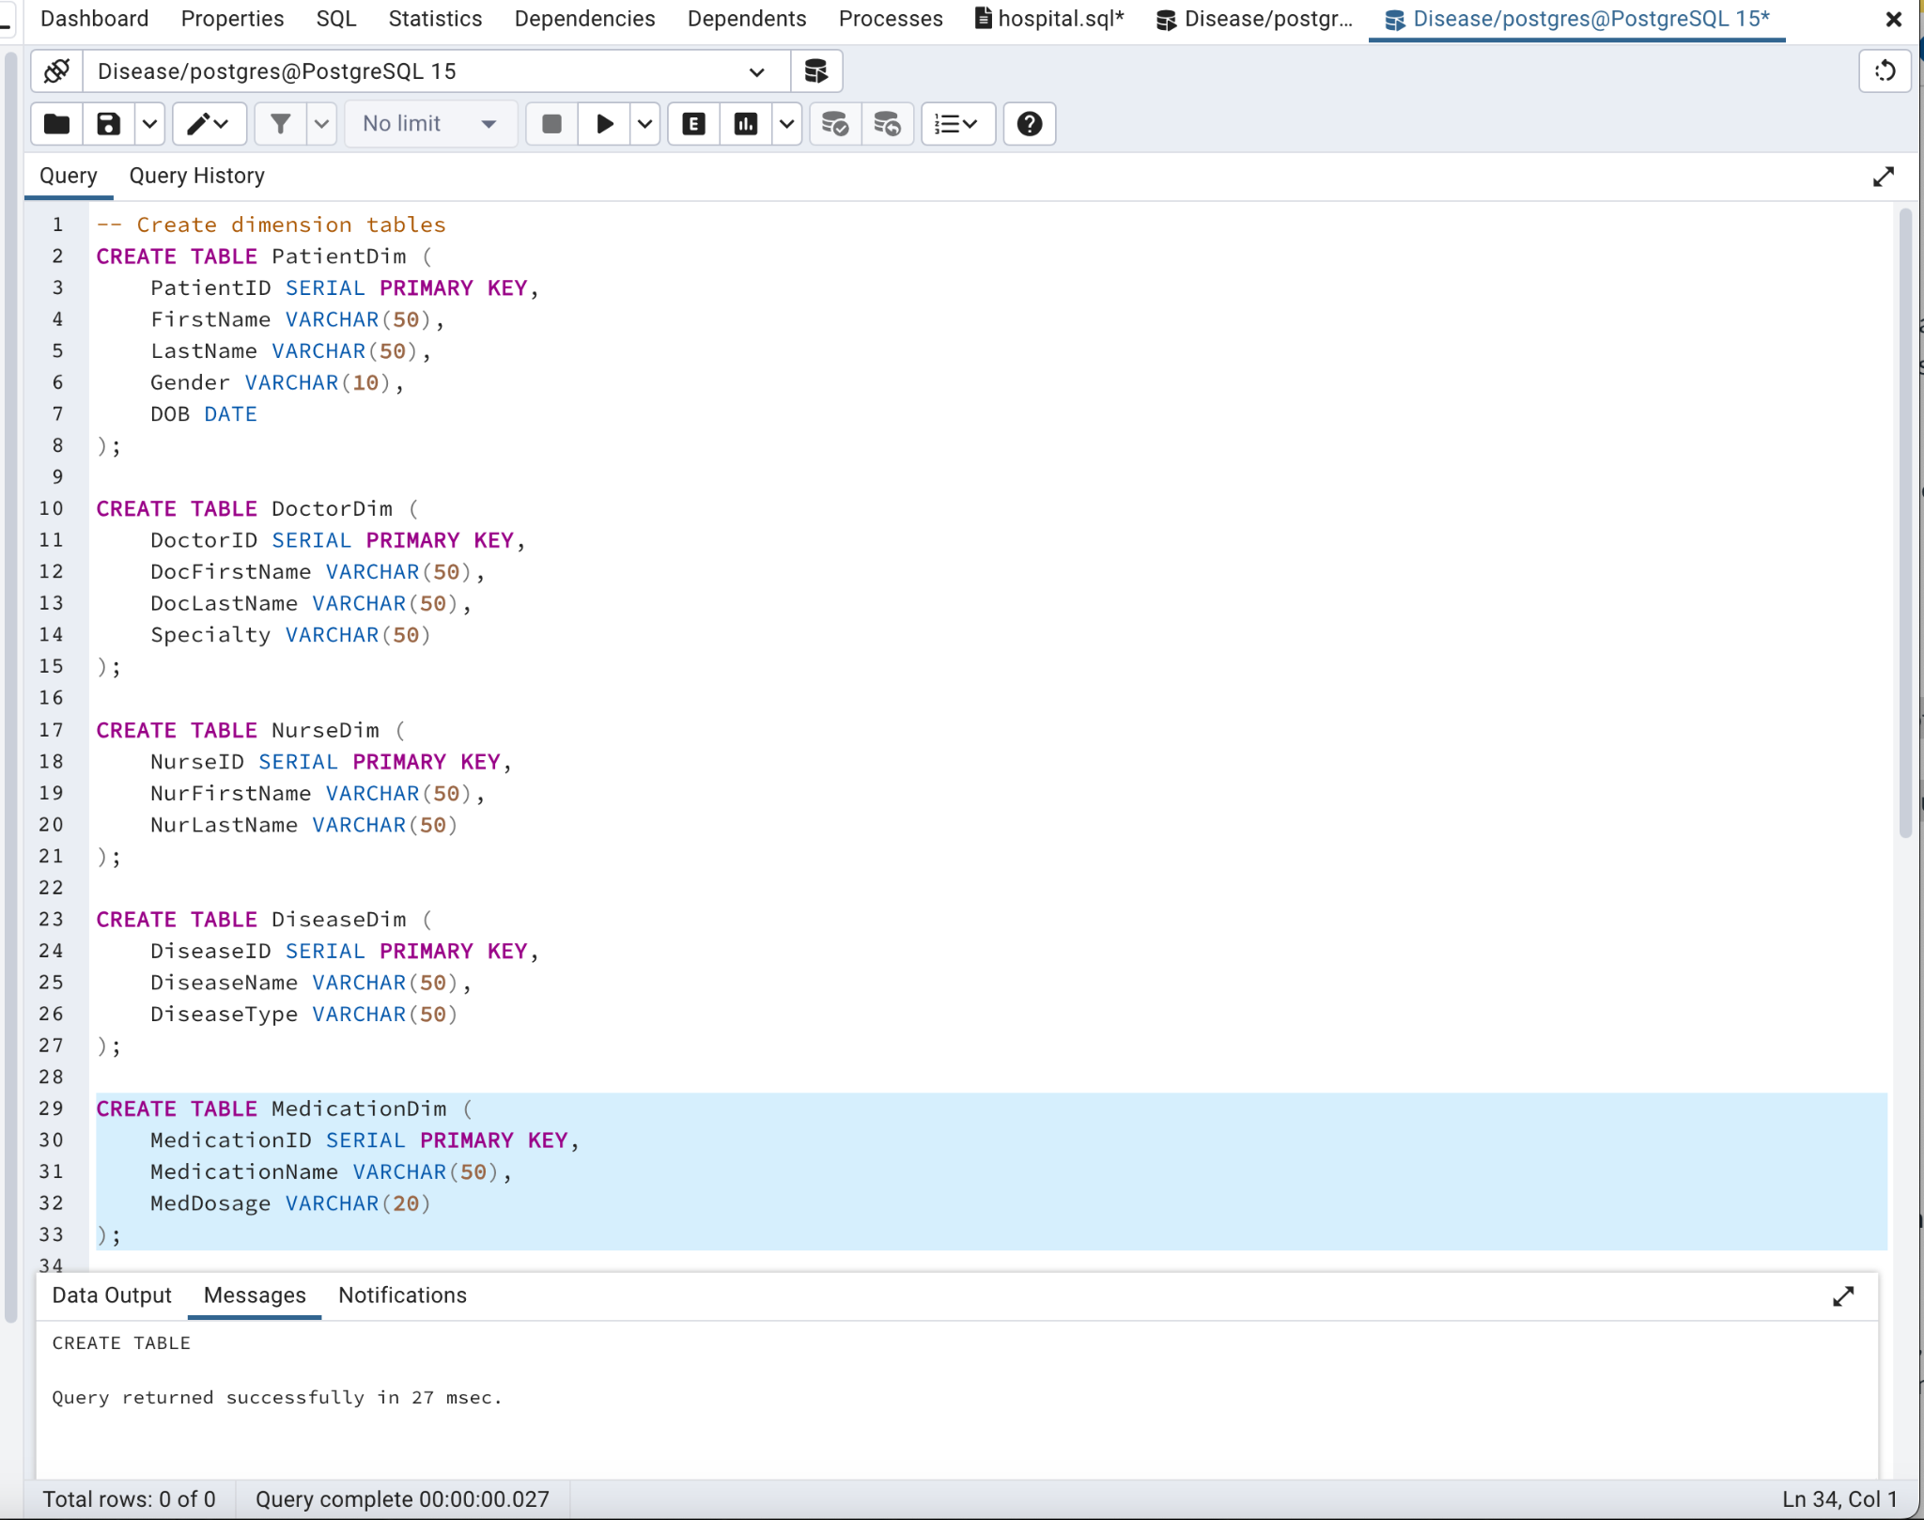

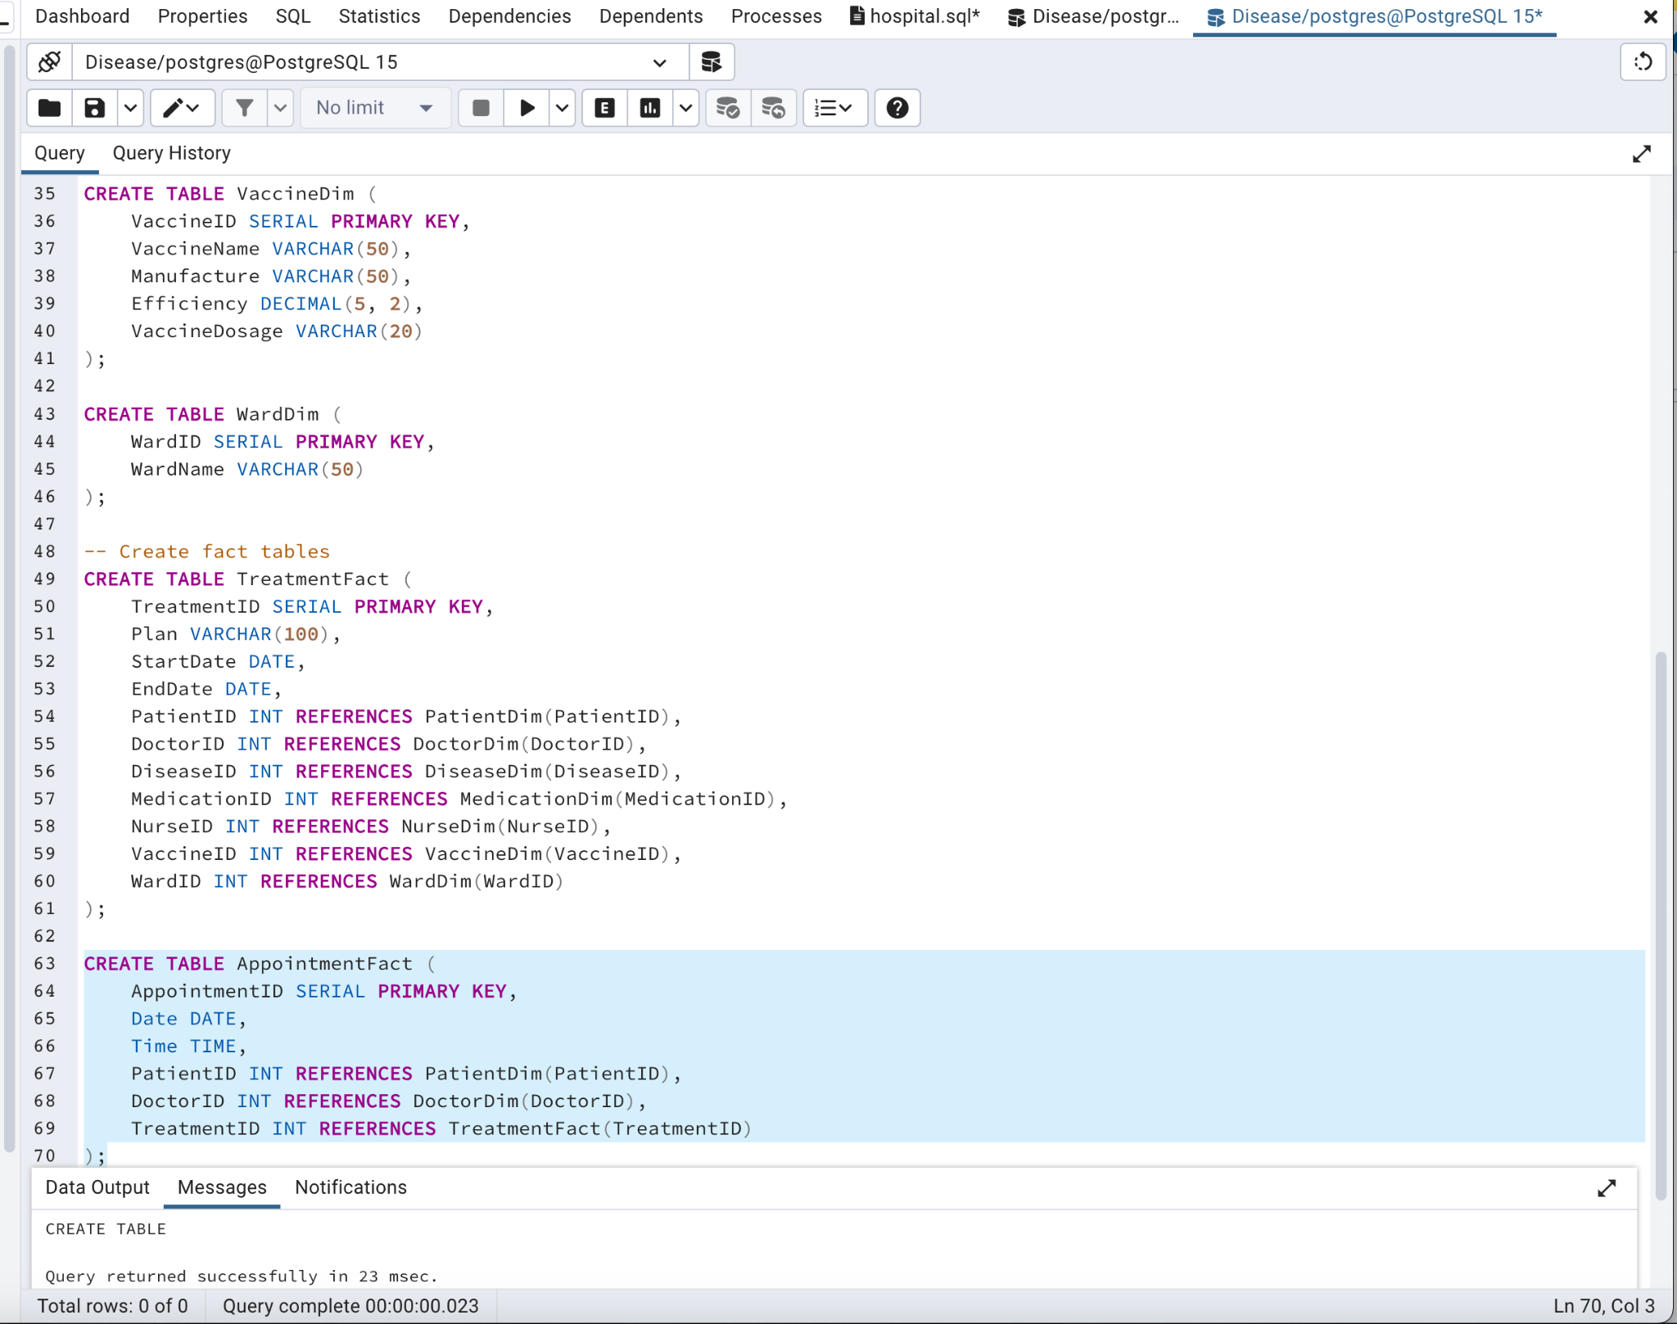

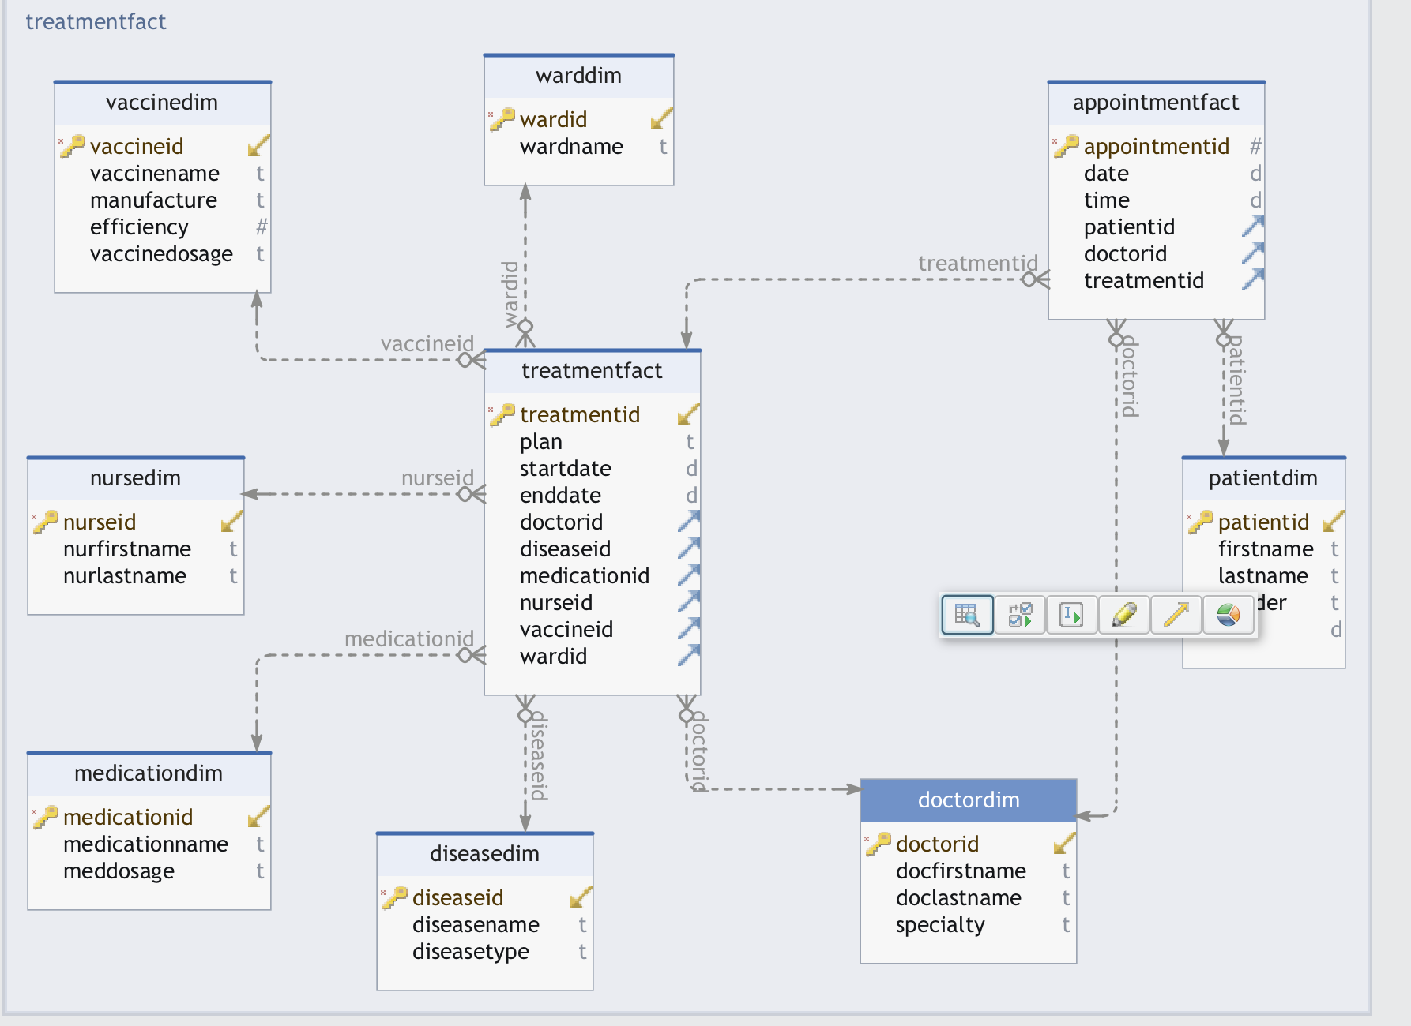

-- Extract and Load Patient Dimension

INSERT INTO disease_dw.PatientDim (PatientID, FirstName, LastName, Gender, DOB)

SELECT PatientID, FirstName, LastName, Gender, DOB

FROM public.Patients;

-- Extract and Load Doctor Dimension

INSERT INTO disease_dw.DoctorDim (DoctorID, DocFirstName, DocLastName, Specialty)

SELECT DoctorID, DocFirstName, DocLastName, Specialty

FROM public.Doctors;

-- Extract and Load Nurse Dimension

INSERT INTO disease_dw.NurseDim (NurseID, NurFirstName, NurLastName)

SELECT NurseID, NurFirstName, NurLastName

FROM public.Nurses;

-- Extract and Load Ward Dimension

INSERT INTO disease_dw.WardDim (WardID, WardName)

SELECT WardID, WardName

FROM public.Hospital_Wards;

-- Extract and Load Disease Dimension

INSERT INTO disease_dw.DiseaseDim (DiseaseID, DiseaseName, DiseaseType)

SELECT DiseaseID, DiseaseName, DiseaseType

FROM public.Diseases;

-- Extract and Load Medication Dimension

INSERT INTO disease_dw.MedicationDim (MedicationID, MedicationName, MedDosage)

SELECT MedicationID, MedicationName, MedDosage

FROM public.Medications;

-- Extract and Load Vaccine Dimension

INSERT INTO disease_dw.VaccineDim (VaccineID, VaccineName, Manufacture, Efficiency, VaccineDosage)

SELECT VaccineID, VaccineName, Manufacture, Efficiency, VaccineDosage

FROM public.Vaccine;

-- Extract and Load Treatment Fact

INSERT INTO disease_dw.TreatmentFact (TreatmentID, Plan, StartDate, EndDate, DoctorID, DiseaseID, MedicationID, NurseID)

SELECT

t.TreatmentID, t.Plan, t.StartDate, t.EndDate,

d.DoctorID, dis.DiseaseID, m.MedicationID, n.NurseID

FROM

public.Treatments t

JOIN public.Doctors d ON t.DoctorID = d.DoctorID

JOIN public.Diseases dis ON t.DiseaseID = dis.DiseaseID

JOIN public.Medications m ON t.MedicationID = m.MedicationID

JOIN public.Nurses n ON t.NurseID = n.NurseID;

-- Extract and Load Appointment Fact

INSERT INTO disease_dw.AppointmentFact (AppointmentID, Date, Time, PatientID, DoctorID, TreatmentID)

SELECT

a.AppointmentID, a.Date, a.Time,

p.PatientID, d.DoctorID, t.TreatmentID

FROM

public.Appointments a

JOIN public.Patients p ON a.PatientID = p.PatientID

JOIN public.Doctors d ON a.DoctorID = d.DoctorID

JOIN public.Treatments t ON a.TreatmentID = t.TreatmentID;

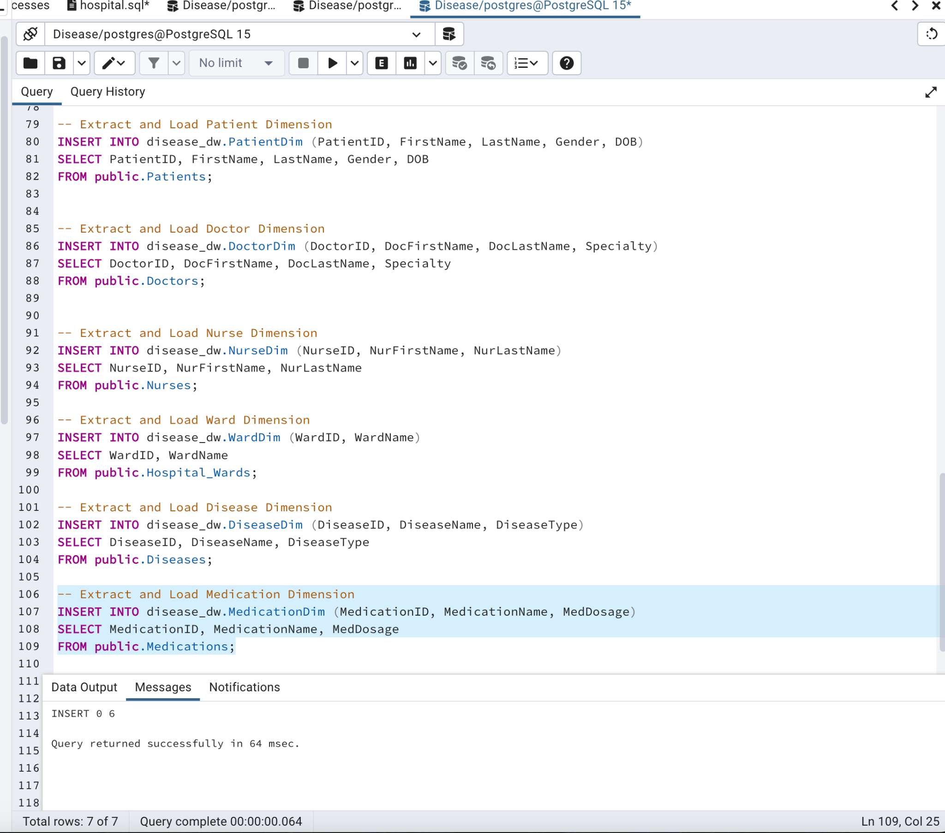

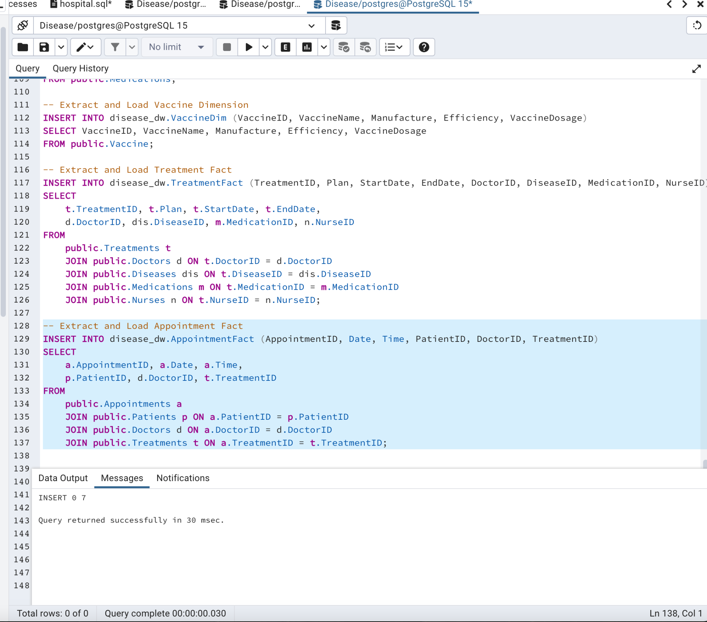

Analytical queries

-- Count of Patients by Gender:

SELECT Gender, COUNT(*) AS PatientCount

FROM disease_dw.PatientDim

GROUP BY Gender;

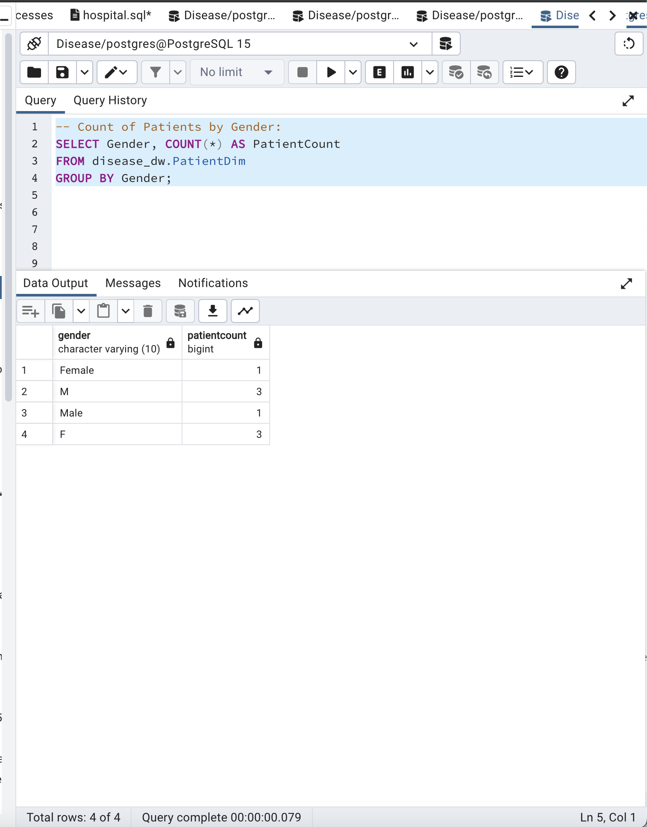

--Top 5 Doctors by Number of Appointments:

SELECT d.DocFirstName, d.DocLastName, COUNT(a.AppointmentID) AS AppointmentCount

FROM disease_dw.DoctorDim d

JOIN disease_dw.AppointmentFact a ON d.DoctorID = a.DoctorID

GROUP BY d.DocFirstName, d.DocLastName

ORDER BY AppointmentCount DESC

LIMIT 5;

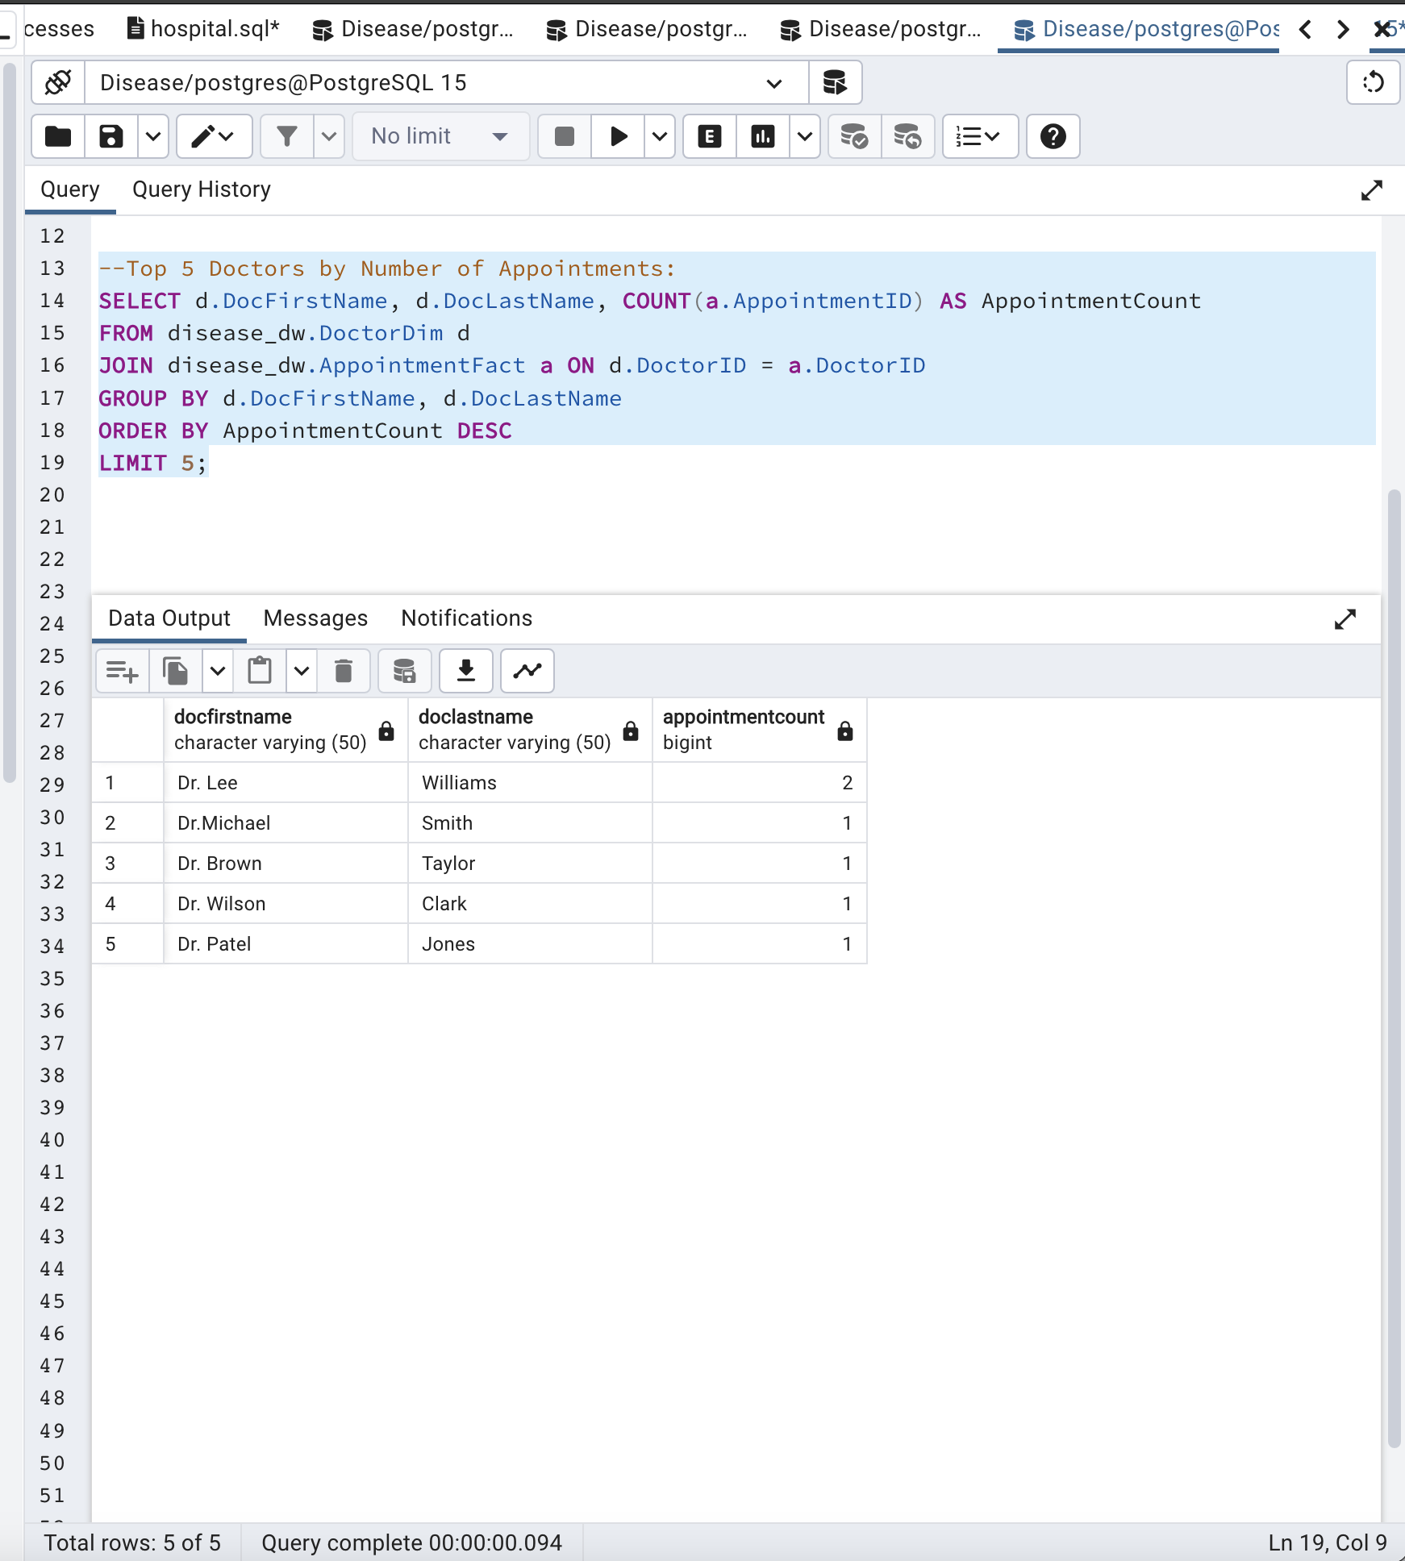

--Average Efficiency of Vaccines:

SELECT AVG(Efficiency) AS AverageEfficiency

FROM disease_dw.VaccineDim;

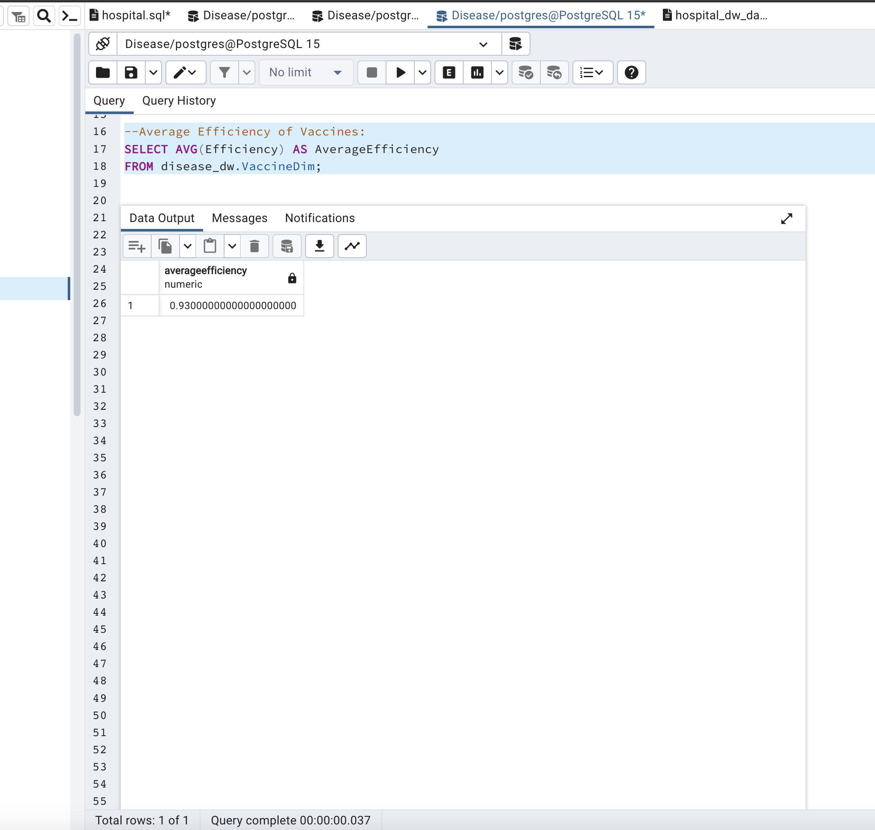

--Number of Patients Treated for Each Disease:

SELECT dis.DiseaseName, COUNT(*) AS PatientCount

FROM disease_dw.DiseaseDim dis

JOIN disease_dw.TreatmentFact t ON dis.DiseaseID = t.DiseaseID

GROUP BY dis.DiseaseName;

